**Epistemological Uncertainties in Planning Education: The Transformative Role of Studio Pedagogy**

**Begüm Eser, T.Kerem Koramaz**

Istanbul Technical University

[eserb18@itu.edu.tr](mailto:eserb18@itu.edu.tr); [koramaz@itu.edu.tr](mailto:koramaz@itu.edu.tr)

**Abstract**

Planning education faces a persistent challenge: equipping planners with the knowledge and skills to navigate an increasingly uncertain and complex world. As Ferreira, Sykes and Batey (2009) metaphorically describe it, planning theory resembles the mythical multi-headed creature, the Hydra, in that it lacks a single dominant paradigm and is made up of multiple paradigms that coexist.The evolving nature of planning theory raises critical questions: This paper argues that studio pedagogy is a critical tool in equipping students with the necessary skills to respond to contemporary urban challenges. By repositioning studio pedagogy as a transformative learning environment, this study contributes to the debate on how planning education can better respond to contemporary socio-spatial challenges. We believe that a pedagogical transformation that goes beyond theoretical teaching and actively prepares students for the uncertainties and ethical complexities of professional planning practice is essential.

**Keywords:** planning theory; planning education; studio pedagogy; transformative learning

**1. INTRODUCTION**

Planning theory has been shaped by the successive and intertwined coexistence of different paradigms. The rationalist and technocratic approaches of the modernist era have gradually been criticised and replaced by more pluralistic and interpretive perspectives. In the postmodern condition, planning theory no longer adheres to a single dominant framework; instead, it has developed into a multi-paradigmatic structure marked by ongoing transformation. As Ferreira, Sykes and Batey [(2009)](https://www.zotero.org/google-docs/?bQtFs6) metaphorically describe it, planning theory resembles the mythical multi-headed creature, the Hydra, in that it lacks a single dominant paradigm and is made up of multiple paradigms that coexist.

Rather than resting on a singular body of knowledge or method, planning exhibits a contextual, relational, and layered epistemological structure. This inherent diversity gives rise to a fundamental question: what types of knowledge should planning prioritise? Davoudi & Pendlebury [(2010, p. 638)](https://www.zotero.org/google-docs/?mjGQ1V) identify three key areas: (1) space as the core object of inquiry; (2) the nature of integrative knowledge; and (3) the interface between knowledge and action. It is precisely through the infusion of disciplinary and experiential knowledge that planning has carved out a distinctive position within the family of social sciences. What distinguishes planners from, for instance, geographers, is not only their critical thinking about space and place, but their aspiration to transform them [(Davoudi, 2009)](https://www.zotero.org/google-docs/?gMKJsb). Planning is thus a mode of doing—an epistemic field grounded in action and interaction, in which knowledge becomes operative in shaping spatial futures .

This dynamic, practice-oriented nature of planning inevitably finds reflection in its educational practices and pedagogical structures. Planning education is a site of reflexive engagement with the evolving paradigms of planning theory. Jane Rendell [(2013)](https://www.zotero.org/google-docs/?ZKY9C2) states that disciplinary uncertainties and boundaries create *a productive transitional space.* In this spirit, this text rethinks the uncertainties at the boundaries of the planning discipline not as deficits or dilemmas, but as spaces of strategic potential and intellectual creativity.

Yet it is precisely this multidimensional character of the discipline that perpetuates a sense of crisis in planning education. As Kunzmann [(Kunzmann, 1985, p. 442)](https://www.zotero.org/google-docs/?RPM8Hk) notes, planning education has been *in crisis* since its inception and will continue to be so, but this should not be seen as a weakness. The inherent complexity of planning demands a pedagogical approach that is reflective, adaptive, and dynamic. To better understand how these transformations have shaped planning education, one must revisit the changing role of the studio, which was foundational to the discipline’s early formation.

In this context, understanding the transformation of planning education is critical for assessing today's spatial, political, and ecological crises and building an effective pedagogical framework for the future. This study explores the following research question: How can studio pedagogy be used as a transformative learning environment to equip planning students with the knowledge and skills necessary to navigate contemporary socio-spatial challenges and epistemological uncertainties in planning education? In line with this question, the research will employ reflexive and situated learning methods.

**2. PARADIGMATIC SHIFTS IN PLANNING EDUCATION AND THE EVOLUTION OF STUDIO PEDAGOGY**

The planning discipline, unlike empirical sciences, deals with wicked problems that require a specific type of (scientific) approach [(Rittel and Webber, 1973, p. 160)](https://www.zotero.org/google-docs/?AJP8JV). Because of this complexity, planning necessitates a comprehensive and integrative educational model that operates independently from the disciplines it is traditionally associated with [Rooij and Frank, 2016, p. 483)](https://www.zotero.org/google-docs/?yS3BTx).

One of the most significant shifts in planning education emerged during the “social turn,” when the discipline began to embrace a social science orientation. The evolution of studio pedagogy has been shaped by broader paradigm shifts in planning education. In response to urban issues of the late 1960s and early 1970s, planning discipline adopted a social science orientation, which changed planning education in a broad way, and in particular the definition of 'studio' as a pedagogical approach [(Wetmore and Heumann, 1988)](https://www.zotero.org/google-docs/?qlYM4u). As planning education reoriented itself, studio courses in planning curricula were gradually reduced in some curricula, and in some planning schools they are only offered in the last semester. This reorientation in planning education can be described as a *hidden curriculum* [(Baum, 1997)](https://www.zotero.org/google-docs/?MjGioh) that transforms practice-oriented teaching.

A similar transformation can be observed in the context of Turkey. With the first planning department established in 1961, planning education was initially carried out with a more physical design-oriented approach. However, over time, the influence of social sciences has increased and the direction of planning education has changed, especially after 1980 with the impact of neoliberal policies. Despite this, studios have continued to exist as an essential component of practice-based pedagogy.

Whether planning is primarily understood as a social science or a design discipline, both traditions remain integral to the field; however, there may still be differences in focus and priorities [(Biggs and Büchler, 2011)](https://www.zotero.org/google-docs/?Qj1l4d). By the late 1990s and early 2000s—what [(Anacker, 2024)](https://www.zotero.org/google-docs/?bWyjAC) refers to as the fourth era of planning—the studio once again became a subject of planning education research, reflecting a renewed interest in practice-based education and studio-based learning.

To respond to the complexities of contemporary urban life, we argue that studio pedagogy must be repositioned as a critical and transformative site of learning. By repositioning studio pedagogy as a transformative learning environment, this study contributes to the debate on how planning education can better respond to contemporary socio-spatial challenges. We believe that a pedagogical transformation that goes beyond theoretical teaching and actively prepares students for the uncertainties and ethical complexities of professional planning practice is essential.

**3. THE RETURN OF THE STUDIO: PEDAGOGICAL POTENTIALS IN TIMES OF CRISIS**

We argue that two key dynamics triggered the return of the studio in planning schools: (1) The Rise of Neoliberalism and the Importance of Space and (2) Ecological Thresholds and Social Inequalities. The strength of studio pedagogy lies not only in its capacity as a medium in which theoretical knowledge is transmitted and practice is learnt, but also in its capacity to encourage students to question the way they think when making ethical and political decisions.

1. The Rise of Neoliberalism and the Importance of Space: Davoudi [(2017)](https://www.zotero.org/google-docs/?VT9mnn) argues that the resurgence of spatial planning in the 2000s was a response to an awareness of the importance of space. She links this to two theoretical developments: (1) relational space and (2) communicative action.
2. Ecological Thresholds and Social Inequalities: Increasing income inequality, housing problems, social exclusion, and crises related to food and water rights directly affect the content of planning. It is crucial to acknowledge that neoliberal policies not only exacerbate spatial inequalities, ecological crises, and social vulnerabilities but also utilise planning tools in the process.

In this context, understanding the transformation of planning education is critical for assessing today's spatial, political, and ecological crises and building an effective pedagogical framework for the future. By examining how planning theory translates into pedagogy, this study offers a framework for integrating equity and sustainability into planning education, ensuring that studio pedagogy evolves in response to contemporary crises. To make this evolution meaningful, it is necessary to understand not only what issues studios address, but how they function as environments for learning and transformation. In this regard, the studio’s pedagogical structure becomes as important as its thematic content.

Studio teaching methods typically follow a “learning by doing” pedagogy [(Schon, 1985)](https://www.zotero.org/google-docs/?mSGtzg). Studios are environments where students actively engage in place-based problem solving [(Neuman, 2016)](https://www.zotero.org/google-docs/?R4oich), negotiating semi-structured and open-ended real-world problems situated within a physical and social context [(Alizadeh, Tomerini and Colbran, 2017)](https://www.zotero.org/google-docs/?apA5ay). One of the most influential studies on design education, Nigel Cross’s *Designerly Ways of Knowing* [(Cross, 1982)](https://www.zotero.org/google-docs/?EeavVo), argues that much of what designers know about their own problem-solving processes remains as “tacit knowledge,” which they struggle to externalise—thus leading design education to rely heavily on an apprenticeship model. Therefore, it is essential to investigate this tacit knowledge within studio courses: how it is produced, and how students discover and engage with it. It is crucial to articulate the specific learning characteristics associated with studio pedagogy and to evaluate its potential and limitations in addressing contemporary challenges in urban and regional planning education.

**4. THE CASE OF “BAŞKA TÜRLÜ STÜDYO” IN PLANNING EDUCATION**

As discussed in previous sections, the contemporary return of the planning studio demands not only a reconsideration of pedagogical form, but also a reimagining of the kinds of knowledge and practices that planning education should cultivate. To explore this further, this section presents a pedagogical experiment conducted in the third-semester undergraduate planning studio at Istanbul Technical University (ITU) during the 2022–2023 fall term. Titled *Başka Türlü Stüdyo* (Another Kind of Studio), this studio engaged cinematic techniques as a tool for spatial inquiry, offering a concrete example of how epistemological uncertainty and multidimensional knowledge can be translated into pedagogical method.

The studio was designed as a method-oriented inquiry into housing site planning and design, focused on the city of Gömeç in Balıkesir, located in western Türkiye. Drawing from site visits and grounded in everyday life observations, the studio was structured around the use of *cinematographic products and techniques* as a method for tracing spatial knowledge. The pedagogical intention was to reverse the traditional shift from upper-scale planning to design and execution, instead shifting from life scale to upper scale, based on human experiences and the immediate environment. Although this may seem very challenging for second-year students at the beginning of their planning education, they were able to adapt to this shift in scale while also benefiting from their first-year interdisciplinary studio experience. This intentional disruption of scalar hierarchy functioned as part of the studio’s hidden curriculum (Purpel, 1983), fostering a transition from top-down planning approaches to bottom-up, situated spatial exploration.

The *Başka Türlü Stüdyo* unfolded through a carefully sequenced structure designed to foster a shift in how students perceive and represent space. The studio’s workflow was structured in three key phases: (1) Field-Based cognitive mapping:, (2) Cinematic representation and analysis, and (3) Site-specific planning and design proposals. Each phase was underpinned by a different mode of inquiry—experiential, visual, and design-based—integrated into a broader pedagogical narrative.

1. Field-Based cognitive mapping: In the first phase, students conducted fieldwork in Gömeç and collected qualitative data on urban, ecological, and social dynamics. Their observations were translated into cognitive mappings enriched by direct quotes, personal impressions, everyday life images, and informal material evidence. The goal was to generate layered and situated understandings of space through lived experiences and affective readings of the site.

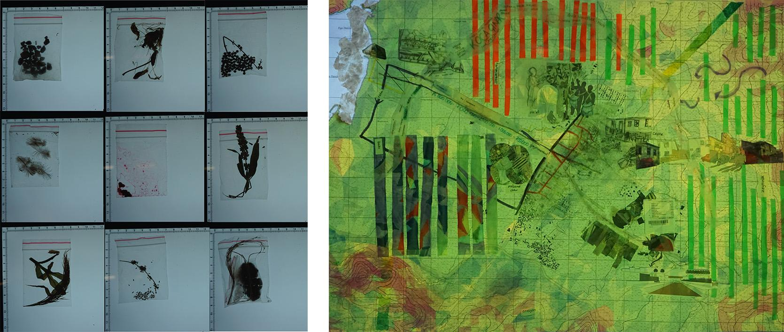

**Figure1:** Field-Based Cognitive Mapping

1. Cinematic representation and analysis: The second phase introduced cinema as a speculative research method. Students were asked to select a film of their choice—without genre or region constraints—provided that the film depicted domestic life and housing environments. They produced hand-drawn storyboards of key scenes, analysed the everyday rituals within domestic settings, and speculated on spatial organisation by drawing plans and sections. These interpretations were then transformed into scaled urban plan and physical models representing the film’s spatial universe. This pedagogical strategy reversed the conventional scalar logic of planning education. Instead of beginning with macro-level planning frameworks, students started from the micro-scale of the dwelling unit and gradually expanded their focus to the neighborhood and settlement scale.

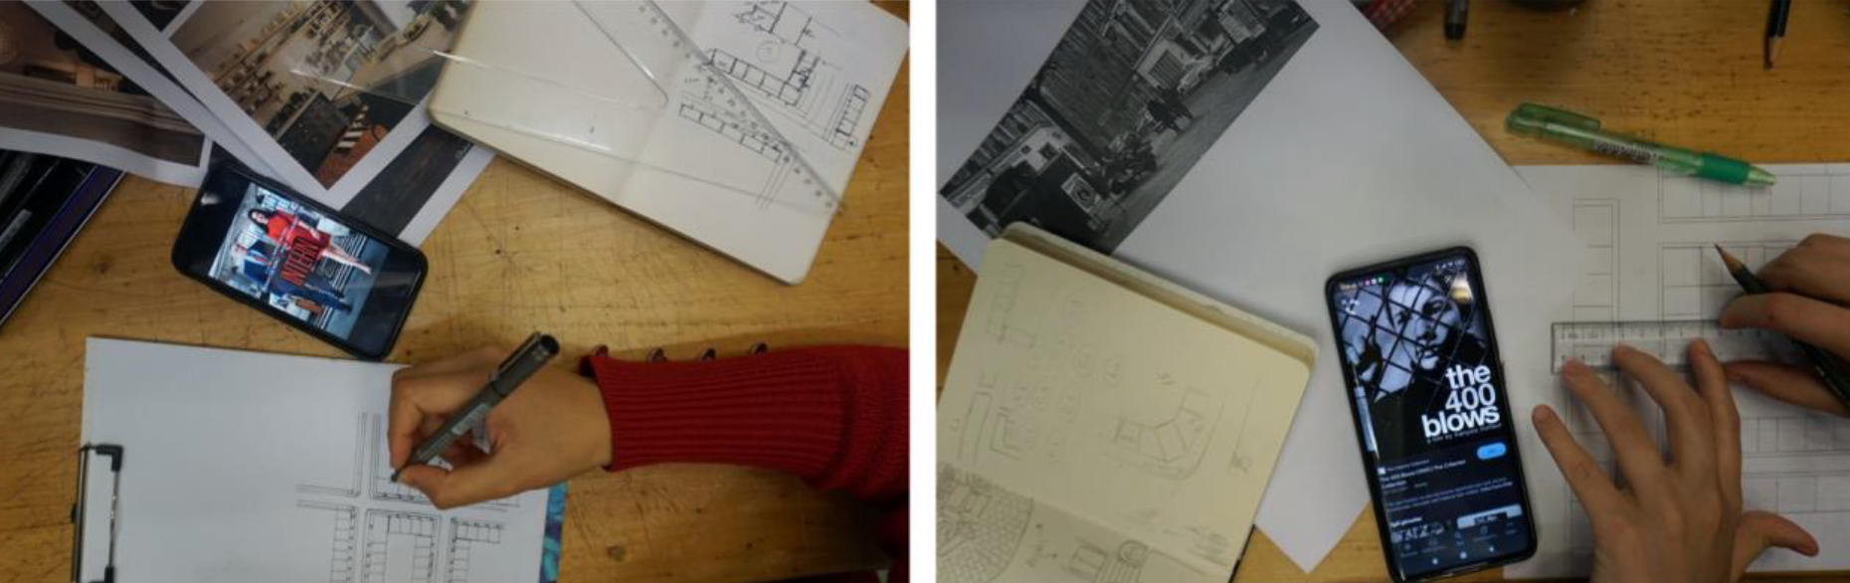

**Figure2:** Cinematic Representation and Analysis

Through this process, they were encouraged to develop a critical awareness of scale, perception, and material representation. By interpreting cinematic environments and transforming them into planning proposals, students navigated the relationship between imagination, representation, and spatial thinking.

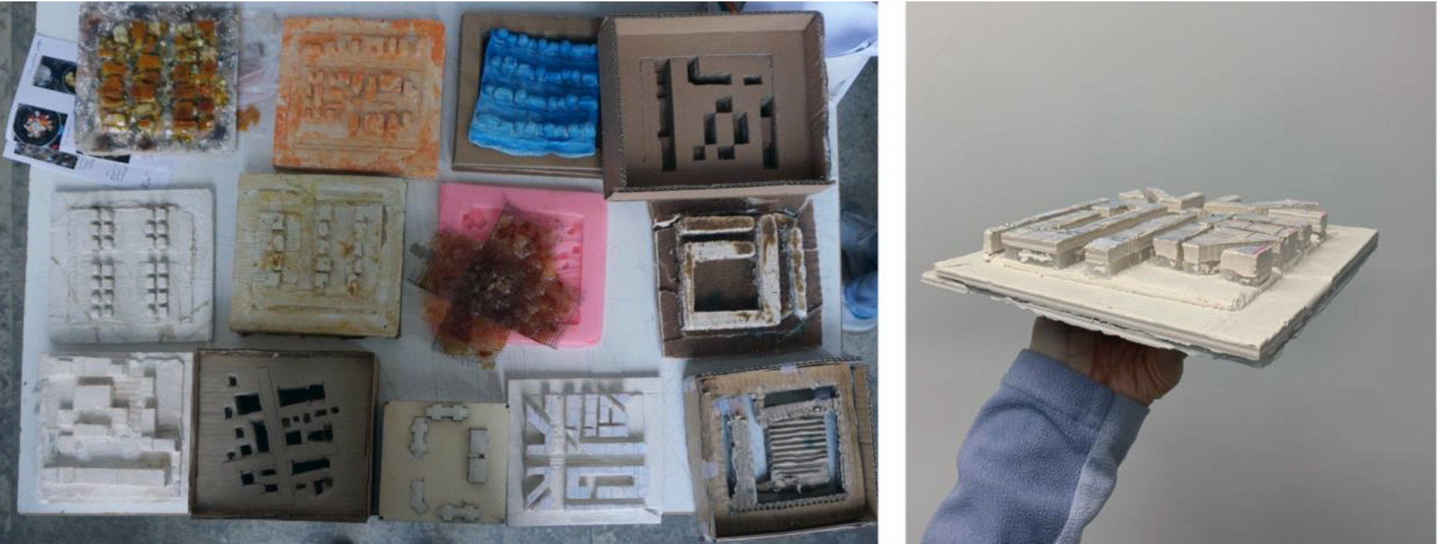

**Figure3:** Models and Material Representation

1. Site-specific planning and design proposals: Drawing on insights from fieldwork and cinematic analysis, students developed comprehensive housing site plans for Gömeç. This phase involved a gradual scalar transition from interior to settlement level, enabling students to grasp the cognitive and practical challenges of spatial scaling. Students produced 1/1000 scale plans that responded to the ecological landscape and local social needs, proposing innovative, context-sensitive, and materially informed housing typologies. The use of experimental materials and model-making techniques encouraged tactile engagement with scale, form, and spatial organisation.

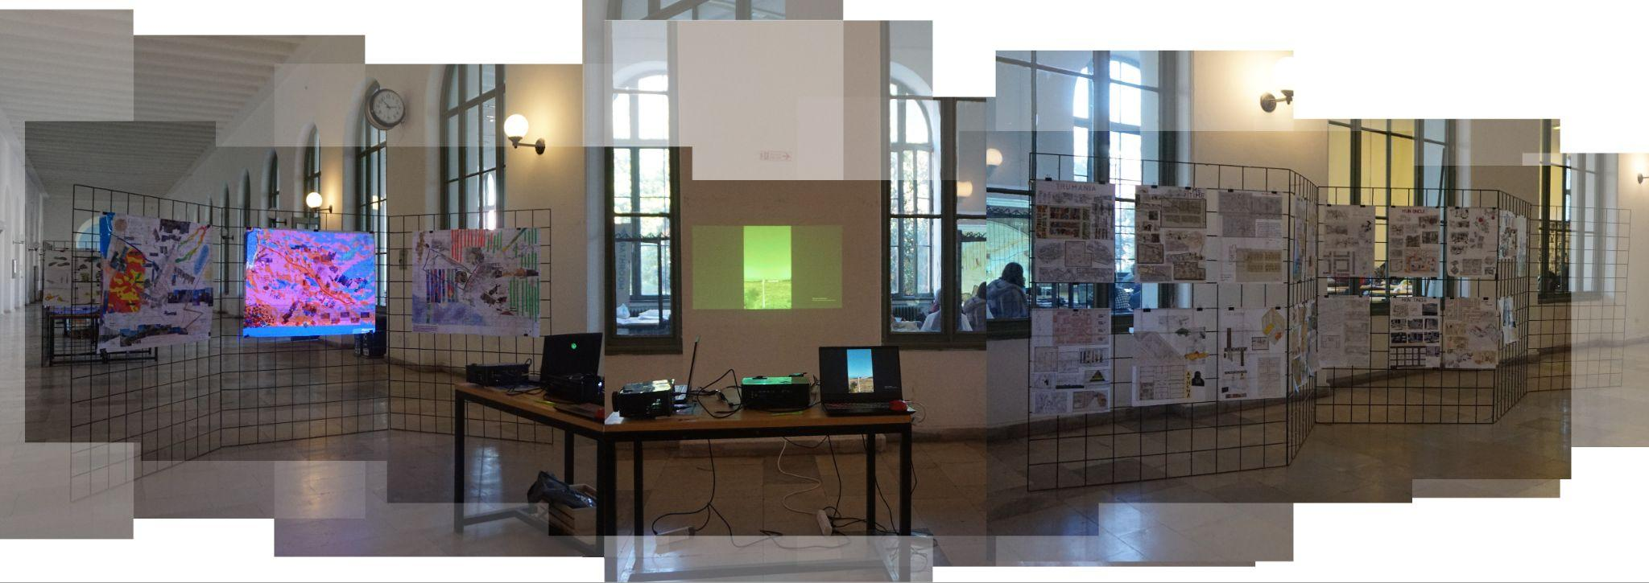

**Figure4:** Exhibition of The *Başka Türlü Stüdyo*

The use of cinematic tools in Başka Türlü Stüdyo served as a valuable medium for enriching the creative studio experience and facilitating students’ perception of urban space across multiple scales. This approach enabled students to transition from an embodied, human-centered perspective to a more analytical, planning-oriented gaze. Through this pedagogical journey, cinema functioned not only as a representational technique but also as a cognitive device that guided students in navigating scalar complexities and engaging critically with spatial transformation.

**5. CONCLUSION**

This paper has explored how planning education can respond to the epistemological multiplicity of planning theory and the pressing crises of our time by rethinking the pedagogical potential of the studio. Beginning with the recognition that planning is a multi-paradigmatic and action-oriented field of knowledge, we examined how educational practices, particularly studio pedagogy, have evolved in tandem with shifts in the discipline’s theoretical foundations.

Through a critical review of historical and contemporary developments, we argued that the studio must be repositioned—not merely as a site for practicing technical skills, but as a generative space for ethical reflection, creative speculation, and spatial imagination. Amidst ecological thresholds, deepening inequalities, and the instrumentalisation of planning under neoliberal regimes, the studio offers a unique pedagogical environment for confronting complex realities.

The *Başka Türlü Stüdyo* case study illustrated how reversing scalar hierarchies and integrating cinematic tools can enable students to navigate between lived experience and planning logic. By centering embodied perception, relational spatial thinking, and visual research, the studio functioned as a performative and reflexive learning environment, opening up new epistemic pathways for planning education.

More broadly, Başka Türlü Stüdyo exemplifies how visual culture and cinematic representation can be embedded into planning education as both an epistemic and creative practice. By positioning cinema as a planning tool, the studio facilitated students’ transition from human-scale spatial perception to rational, studio-based thinking. This process enabled them to connect subjective experience with analytical inquiry. Through experimental techniques, the studio fostered critical engagement with issues such as ecological vulnerability, housing, and social inequality. This pedagogical experiment not only expanded the scope of studio-based learning but also cultivated a socially responsive and ecologically aware planning mindset. It reaffirmed the potential of studio pedagogy to operate as a dynamic interface between narrative imagination, empirical research, and spatial design.

Ultimately, reimagining the studio as a site of uncertainty, experimentation, and learning space the way for a more situated, inclusive, and resilient planning education that is capable of confronting the unknown and cultivating new imaginaries for spatial futures. In this context, understanding the transformation of planning education is critical for assessing today’s spatial, political, and ecological crises and building an effective pedagogical framework for the future.

[Alizadeh, T., Tomerini, D. and Colbran, S. (2017) ‘Teaching Planning Studios: An Online Assessment Task to Enhance the First Year Experience’, *Journal of Planning Education and Research*, 37(2), pp. 234–245. Available at: https://doi.org/10.1177/0739456X16647162.](https://www.zotero.org/google-docs/?25iDlf)

[Anacker, K.B. (2024) ‘The Evolution of the Four Eras of Urban Planning Education in the United States’, *Journal of Planning Education and Research*, 44(4), pp. 2294–2304. Available at: https://doi.org/10.1177/0739456X231177436.](https://www.zotero.org/google-docs/?25iDlf)

[Baum, H.S. (1997) ‘Teaching Practice’, *Journal of Planning Education and Research*, 17(1), pp. 21–29. Available at: https://doi.org/10.1177/0739456X9701700103.](https://www.zotero.org/google-docs/?25iDlf)

[Biggs, M. and Büchler, D. (2011) ‘Transdisciplinarity and New Paradigm Research’, in I. Doucet and N. Janssens (eds) *Transdisciplinary Knowledge Production in Architecture and Urbanism*. Dordrecht: Springer Netherlands, pp. 63–78. Available at: https://doi.org/10.1007/978-94-007-0104-5_5.](https://www.zotero.org/google-docs/?25iDlf)

[Cross, N. (1982) ‘Designerly ways of knowing’.](https://www.zotero.org/google-docs/?25iDlf)

[Davoudi, S. (2009) ‘Planning and interdisciplinarity’, in. *AESOP Heads of School Seminar*.](https://www.zotero.org/google-docs/?25iDlf)

[Davoudi, S. (2017) ‘Spatial Planning’, in M. Gunder, A. Madanipour, and V. Watson (eds) *The Routledge Handbook of Planning Theory*. 1st edn. New York, NY : Routledge, 2018.: Routledge, pp. 15–27. Available at: https://doi.org/10.4324/9781315696072-2.](https://www.zotero.org/google-docs/?25iDlf)

[Davoudi, S. and Pendlebury, J. (2010) ‘Centenary paper: *The evolution of planning as an academic discipline*’, *Town Planning Review*, 81(6), pp. 613–646. Available at: https://doi.org/10.3828/tpr.2010.24.](https://www.zotero.org/google-docs/?25iDlf)

[Ferreira, A., Sykes, O. and Batey, P. (2009) ‘Planning Theory or Planning Theories? The Hydra Model and its Implications for Planning Education’, *Journal for Education in the Built Environment*, 4(2), pp. 29–54. Available at: https://doi.org/10.11120/jebe.2009.04020029.](https://www.zotero.org/google-docs/?25iDlf)

[Kunzmann, K.R. (1985) ‘Educating planners in Europe: trends and requirements - an international perspective’, *Town Planning Review*, 56(4), p. 442. Available at: https://doi.org/10.3828/tpr.56.4.x67130n53544744k.](https://www.zotero.org/google-docs/?25iDlf)

[Neuman, M. (2016) ‘Teaching collaborative and interdisciplinary service-based urban design and planning studios’, *Journal of Urban Design*, 21(5), pp. 596–615. Available at: https://doi.org/10.1080/13574809.2015.1100962.](https://www.zotero.org/google-docs/?25iDlf)

[Rendell, J. (2013) ‘Working Between and Across: Some Psychic Dimensions of Architecture’s Inter- and Transdisciplinarity’, *Architecture and Culture*, 1(1), pp. 128–140. Available at: https://doi.org/10.2752/175145213X13756908698685.](https://www.zotero.org/google-docs/?25iDlf)

[Rittel, H.W.J. and Webber, M.M. (1973) ‘Dilemmas in a general theory of planning’, *Policy Sciences*, 4(2), pp. 155–169. Available at: https://doi.org/10.1007/BF01405730.](https://www.zotero.org/google-docs/?25iDlf)

[Rooij, R. and Frank, A.I. (2016) ‘Educating spatial planners for the age of co-creation: the need to risk community, science and practice involvement in planning programmes and curricula’, *Planning Practice & Research*, 31(5), pp. 473–485. Available at: https://doi.org/10.1080/02697459.2016.1222120.](https://www.zotero.org/google-docs/?25iDlf)

[Schon, D. (1985) *The design studio: an exploration of its traditions and potentials*. London: RIBA Publications for RIBA Building Industry Trust (Architecture and the higher learning).](https://www.zotero.org/google-docs/?25iDlf)

[Wetmore, L.B. and Heumann, L.F. (1988) ‘The Changing Role of the Workshop Course in Educating Planning Professionals’, *Journal of Planning Education and Research*, 7(3), pp. 135–146. Available at: https://doi.org/10.1177/0739456X8800700306.](https://www.zotero.org/google-docs/?25iDlf)