Pursuing total volume or efficiency? A study on the coupling pattern of rural population and space: A case study from Huangyan District, Zhejiang Province, China

Zhuyang LIU, Guiqing YANG*

Affiliation: College of Architecture and Urban Planning , Tongji University

Email: 2330323@tongji.edu.cn

**Abstract**

Under globalization, rural areas worldwide are experiencing population decline and built-space decay. Traditional rural development theories posit a positive correlation between residential population size and built-space efficiency. Following this theoretical assumption, China's eastern coastal villages should follow the trajectory of rural decline observed in developed nations. However, a paradoxical phenomenon of "quantity reduction with quality enhancement" has emerged in some eastern villages, which cannot be adequately explained by conventional "aggregate quantity coupling" models linking population and built space. This study proposes an "efficiency coupling" theoretical framework, demonstrating that rural systems can maintain vitality through spatial efficiency compensation when quantity balance falters. We identify three underlying mechanisms driving this transition and validate the efficiency coupling model through multi-scale case studies in Huangyan District and Shatian Village, Zhejiang Province. The analysis particularly examines Shatian Village's efficiency coupling mechanisms through two critical dimensions: companionship-based planning and multi-stakeholder co-creation. These findings offer new insights for villages grappling with population loss and spatial decay during urbanization processes.

**Keywords**

Quantity; Efficiency; Coupling Modes; Rural Residential Population; Built-up Space

**Introduction**

Under globalization, rural areas worldwide are grappling with dual challenges of residential population loss and built-environment decay[1]. UN-Habitat (2022) data indicates that over half of rural regions have experienced functional degradation since the 21st century, manifested through rising housing vacancy rates, declining utilization of public spaces, and fractured social networks[2]. Scholars such as Gobillon, L. (2003) have further elucidated the mechanisms linking population outflow to rural decline: when residential population density falls below the critical threshold required to sustain built environments, economies of scale in infrastructure vanish, marginal costs of public services surge, and spatial quality enters a downward spiral[3]. This evolutionary trajectory aligns with theories of "shrinking villages" in Europe and North America[4-6], as well as empirical studies on Japan’s "marginal settlements" (genkai shūraku) and "hyper-depopulated villages" (kasoka sonraku)[7]. Against this backdrop, addressing the "hollowed village" dilemma and achieving dynamic equilibrium between population and built space has emerged as a pivotal issue for rural development.

Traditional rural development theories posit a positive correlation between residential population size and utilization efficiency of built-up spaces (Woods, 2011)[8]. Under this theoretical framework, coastal villages in eastern China would ostensibly follow the trajectory of "rural demise" observed in developed nations, as evidenced by statistical trends showing continuous reduction in natural village numbers and unidirectional outflow of registered residents[9]. However, intensive field observations reveal counterintuitive spatial practices: in economically vibrant regions such as the Yangtze River Delta and Pearl River Delta, certain villages demonstrate distinctive adaptive renewal capabilities in their built environments despite experiencing negative population growth. Field investigations by Zhu et al. (2022) further corroborate this phenomenon, showing that 43% of sampled villages in the Yangtze River Delta maintained or enhanced built-space utilization efficiency amidst persistent population outflow[10]. This paradoxical phenomenon of "quantitative contraction and qualitative enhancement" challenges conventional population-space equilibrium models, suggesting the emergence of novel systemic balancing mechanisms.

The theory of spatial production provides a critical lens for deconstructing this paradox. Lefebvre's (1984) triadic spatial dialectic posits that when the material function of physical space becomes decoupled from residential population size, dynamic equilibrium within the system can be achieved through the reconstruction of spatial representations[11]. Empirical cases from eastern Chinese villages demonstrate that traditional farmhouses, through functional conversion into cultural-creative spaces, not only preserve their material structures but also reconfigure the social value of built environments (Zhang et al., 2025)[12]. This process of "spatial re-territorialization" (Brenner, 1999) fosters novel coupling mechanisms[13]: despite persistent outflows of permanent residents, the adaptive recalibration of built-space functions alongside periodic influxes of mobile populations sustains or even enhances spatial utilization efficiency (Yunqi Guo, 2024)[14].

Building upon conventional "aggregate coupling" frameworks, this study proposes an "efficiency coupling" theoretical paradigm: rural systems can sustain robust functionality when built-space efficiency compensates for quantitative imbalances. This transformation is fundamentally driven by three mechanisms: First, adaptive retrofitting of rural built environments through the integration of agricultural production spaces with emerging industries such as cultural consumption and e-commerce; Second, innovative preservation and creative reinterpretation of historical-cultural resources, enabling traditional villages to undergo metamorphosis and revitalization; Third, urban creative cohorts, empowered by digital media and social networks, emerging as novel users and critical stakeholders in rural built-space utilization, actively engaging in community co-governance. These mechanisms collectively facilitate "efficiency re-coupling"—achieving enhanced output per unit area through spatial intensification, even as residential population density declines.

This theoretical framework demonstrates three distinctive innovations compared to existing paradigms: First, diverging from Western-centric concepts of rural gentrification (Smith, 2002) [15-16]or amenity migration (Gosnell & Abrams, 2011)[17], the Chinese model reveals unique advantages in government-market collaborative governance. Village collectives, through coordinated land consolidation leasing and joint development with market entities (Zhou, L., 2024)[18], construct hybrid governance structures that transcend institutional path dependence. Practically, the proposed efficiency-coupling framework advances beyond traditional quantitative equilibrium analyses by establishing an efficiency-oriented evaluation system for rural built environments, offering an Eastern perspective to "smart shrinkage" theory (Hollander, 2018)[19]. Methodologically, the study innovatively integrates census data to track demographic shifts, POI data to decode rural functional transitions, and multi-temporal remote sensing imagery (2000–2022) for land-use change detection, thereby developing novel tools for quantifying population-space adaptation. Ultimately, these findings align with China’s new-type urbanization and dual-circulation development strategies, while providing actionable insights for resolving the paradox of "population decline versus spatial underutilization" in rural revitalization.

# **Literature Review and Theoretical Framework**

## **1.1 Aggregate Coupling Model**

Existing research on the coupling between residential population and built-up spaces predominantly focuses on absolute coupling, which posits that within a defined geographical unit, the total residential population and the scale of built-up spaces must adhere to a "rigid matching" principle. This hypothesis underscores an absolute correspondence between population and spatial capacity, asserting that the number of residents in a specific area must strictly align with the available spatial scale to achieve efficient resource utilization and rational spatial allocation. Deviations beyond established threshold intervals are theorized to trigger systemic risks, including resource mismatches, infrastructure vacancy, and economic decline (see Figure 1).

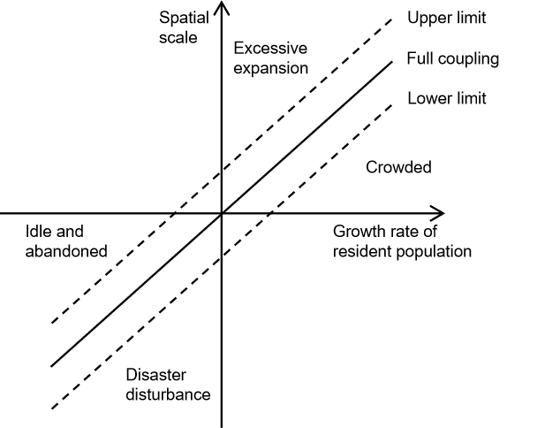

Figure 1 Traditional Resident Population–Built Space Coupling Model

To quantify such imbalances, scholars have introduced the Residential Population-Land Urbanization Index (α), defined as:

α = DR / LR

where α represents the coupling coefficient between residential population urbanization (DR, annualized change rate of population urbanization level) and land urbanization (LR, annualized change rate of spatial expansion). An α value of 1 indicates synchronized progression of population and land urbanization; α > 1 signifies spatial overexpansion relative to population growth, while α < 1 reflects population agglomeration outpacing spatial supply. Empirical evidence from international studies suggests that regions with sustained α values exceeding 1.2 consistently surpass the 15% critical threshold for vacant land ratios.

## **1.2 Efficiency Coupling Model**

The absolute coupling model between residential population and built-up spaces establishes linear correlations to provide a quantitative diagnostic framework for urban shrinkage and rural hollowing. However, this paradigm reduces complex human-environment interactions to static correspondences, overlooking dynamic feedback mechanisms between systems and underestimating the built environment’s capacity for resilient adaptation under population decline. Consequently, it struggles to explain empirical phenomena in rural China, where sustained population outflows coexist with “contraction without decline” or even “reverse revitalization” outcomes.

Building on traditional “aggregate coupling” principles, this study proposes a theoretical framework for the Residential Population-Built Space Efficiency Coupling Model. The framework posits that spatial efficiency can compensate for quantitative imbalances through resilient adaptation strategies—such as functional repurposing of spaces and adaptive reuse of structures—to maintain or enhance spatial performance despite population loss, thereby sustaining systemic viability in rural areas.

This transformation is fundamentally driven by three mechanisms: First, adaptive retrofitting of rural built environments is propelled by industrial shifts, such as converting agricultural production spaces into cultural consumption hubs or e-commerce facilities. Second, innovative preservation and creative reinterpretation of historical and cultural resources enable traditional villages to revitalize through heritage-led regeneration. Third, under the influence of digital media and social networks, urban innovators (e.g., digital entrepreneurs, cultural creators) emerge as new users and key stakeholders in co-managing rural built spaces.

The efficiency coupling paradigm challenges traditional developmentalist approaches by prioritizing functional transformation and spatial innovation over population retention. Theoretically, it repositions built spaces as dynamic productive assets rather than passive containers. Practically, it offers innovative pathways for rural revitalization that transcend simplistic narratives of reversing population outflows.

# **2. Research Methodology and Case Selection**

## **2.1 Study Area Overview**

This study selects Huangyan District in Zhejiang Province as a representative case, given its significance in reflecting urban-rural transition dynamics in China’s developed coastal counties. Statistical data reveal that from 2020 to 2022, the rural population in Huangyan District decreased from 261,745 to 255,150—a reduction of 6,595 residents[20]. However, through spatial functional restructuring and capital infusion, the district had established 30 provincial-level beautiful villages by the end of 2022[21]. This paradoxical phenomenon of “population outflow alongside spatial upgrading” underscores the complexity of rural system restructuring under China’s new urbanization paradigm, where demographic decline does not inevitably lead to spatial decay but may instead enhance the coupling efficiency between residential populations and built environments.

For a micro-scale analysis of the “high-efficiency coupling” model between residential populations and built spaces under new media-driven community co-management, this study further selects Shatian Village in Yutou Township as a nested case. Located in the southeastern part of Yutou Township, Huangyan District, Taizhou City, Zhejiang Province, Shatian Village experienced a period of decline after the relocation of the Yutou Township government in the late 1990s. However, leveraging the national Qianwan Project (Thousand Village Demonstration Project), the village underwent organic renewal under the guidance of Professor Yang Guiqing’s team from Tongji University’s School of Urban Planning and Architecture. Through adaptive spatial transformations, it introduced diversified economic activities such as conference training, tourism, and rural e-commerce, ultimately becoming a provincial-level demonstration village for beautiful habitation.

## **2.2 Data Sources and Processing**

This study employs a multi-source heterogeneous data fusion analysis approach, integrating three primary datasets: population distribution, spatial elements, and land use. Population census data were sourced from the Huangyan District Population Census Yearbook (2010) and Huangyan District Population Census Yearbook (2020), with permanent population statistics aggregated at the administrative village level and supplementary data compiled at the township level.

POI (Point of Interest) data, a core geospatial dataset in digital mapping, represent specific geographic entities such as restaurants, shopping centers, schools, hospitals, and tourist attractions. Each POI is geocoded as a point feature with attributes including name, category, address, and contact information. The POI data used in this study were extracted from Amap (AutoNavi Map) for the years 2015, 2017, 2019, 2021, 2023, and 2025.

Land use data were derived from the SinoLC1 database developed by Wuhan University, featuring 1-meter resolution and 73.61% classification accuracy. The dataset categorizes land cover into 11 types: Tree cover, Shrubland, Grassland, Cropland, Building, Traffic route, Barren and sparse vegetation, Snow and ice, Water, Wetland, and Moss and lichen. The “Building” category, representing built-up spaces, serves as the focal land use class for this research.

# **3. Empirical Analysis: A Case Study of Huangyan District, Taizhou City, Zhejiang Province**

## **3.1 Regional-Level Analysis**

### **3.1.1 Residential Population Dynamics**

This study systematically examines the spatiotemporal evolution of population distribution in Huangyan District using census data and floating population surveys. The findings reveal differentiated development trajectories in the western mountainous and hilly areas: Beiyang and Ningxi Towns have emerged as secondary population agglomeration centers, leveraging their roles as central towns to establish local growth poles. In contrast, townships such as Yutou and Shangzheng, constrained by topographic limitations, exhibit persistently low population densities.

Temporal analysis (2010–2020) demonstrates pronounced spatial heterogeneity in population mobility. Western mountainous townships generally faced population decline, with Shangzheng Township recording the region’s highest negative annual population growth rate. Conversely, Beiyang and Maoshe Townships experienced modest population rebounds, with Maoshe Township showing particularly notable growth trends.

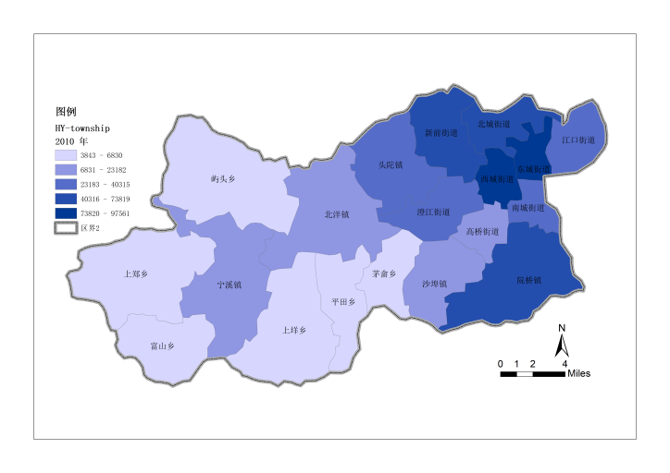

Figure 2a 2010 Permanent Resident Population

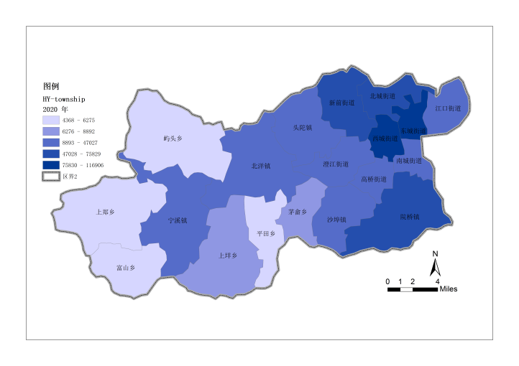

Figure 2b 2020 Permanent Resident Population

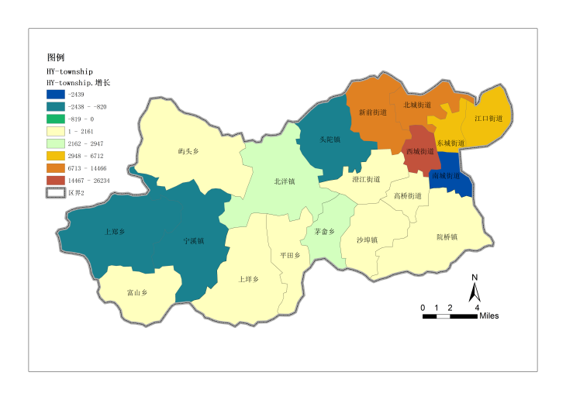

Figure 2c 2010–2020 Permanent Resident Population Change

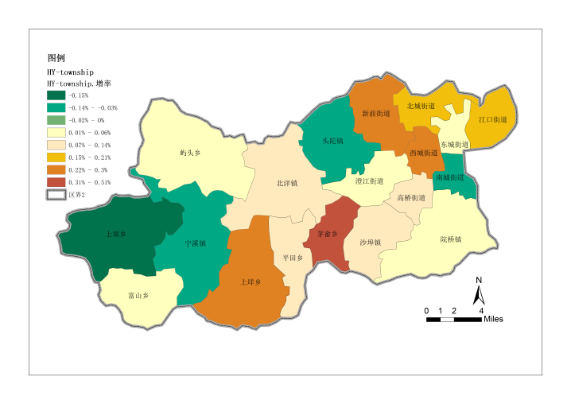

Figure 2d 2010–2020 Permanent Resident Population Growth Rate

Figure 2 Resident Population Statistics in Huangyan District

### **3.1.2 Characteristics of Built-Up Space Distribution**

This study investigates the evolutionary trajectory of built-up areas in Huangyan District, eastern Zhejiang Province, through three temporal cross-sections (2000, 2010, and 2020), revealing phased characteristics and spatial differentiation patterns in urban-rural restructuring. The analysis demonstrates a persistent expansion of built-up spaces in the study area. Between 2000 and 2010, the central urban built-up areas expanded markedly outward, while township-level built-up spaces largely retained their original spatial configurations, with only localized low-intensity infill development.

Post-2010, spatial expansion exhibited a gradient diffusion effect. The central urban areas continued their outward growth, while key western towns entered a phase of rapid built-up area expansion, forming contiguous development zones. Mid-sized townships displayed edge-permeation growth, with built-up spaces extending outward along existing settlement boundaries to create compact spatial forms. Notably, in ecologically sensitive zones, built-up areas in certain townships showed limited scale increases but adopted discrete patch-like distribution patterns, reflecting spatial adaptation strategies for rural construction under ecological constraints.

### **3.1.3 Coupling Characteristics of Residential Population and Built-Up Space**

An analysis of the coupling relationship between residential population size and built-up area changes in Huangyan District from 2010 to 2020 reveals significant differentiation in coupling patterns across townships: Yutou and Maoshe Townships exhibited basic coupling, with slight synchronized growth in both population and built-up areas at comparable rates. In contrast, Shangzheng, Ningxi, and Tuotuo Townships displayed anomalous inverse revitalization patterns, contradicting field observations of spatial stagnation phenomena such as hollowing-out traditional villages and idle rural homesteads. The study hypothesizes that administrative seat towns may attract rural populations through spatial reproduction strategies—such as concentrated educational and medical resources or industrial park development—while ordinary villages continue to face persistent population outflows. To unravel this paradox, further investigation into the micro-scale dynamics of population and built-up space changes at the village level is required.

## **3.2 Village-Level Analysis**

### **3.2.1 Development Overview of Shatang Village**

Shatang Village in Huangyan District was historically a declining settlement plagued by population exodus. Located in the western mountainous and hilly terrain, the village faced dual constraints of inadequate transportation accessibility and diminished regional economic influence due to its complex topography and peripheral location. Although the historic Taiwei Temple complex embodies local cultural and spiritual heritage, its lack of designation as a protected cultural site hindered the conversion of its cultural capital into tourism appeal. As a traditional agrarian village, its spatial organization initially aligned with small-scale farming practices. However, accelerated regional urbanization triggered sustained outmigration of working-age residents, resulting in a hollowed-out demographic structure dominated by elderly populations, which further eroded community vitality. Public space systems deteriorated into disorder due to insufficient maintenance, with alleyway textures eroded by encroaching vegetation and functional streets devolving into waste accumulation zones.

Since 2013, the Tongji University Huangyan Rural Planning team initiated the formulation and implementation of the Beautiful Village Plan for Shatang Village. During built environment optimization, planners adopted acupuncture-style interventions to repurpose vacant farmhouses into multifunctional community service facilities, preserving villagers’ spatial habits while integrating tourism functions. This spatial reproduction strategy effectively revitalized existing architectural resources, enhancing built space utilization efficiency. As environmental quality improved, the village gradually integrated into the regional tourism network, leveraging its strategic position as a key node in the Rou River Scenic Area to attract emerging industries such as educational tourism and cultural innovation.

### **3.2.2 Coupling Characteristics of Residential Population and Built Environment in Shatang Village**

As of the end of 2023, Shatang Village comprises 300 households with a registered population of 1,074. Between 2019 and 2023, the village’s registered population exhibited a gradual decline. According to the Seventh National Population Census, individuals aged 21 or younger account for 22% of the total population, while those aged 60 or older represent 11%.

In 2023, the village’s operational income reached ¥1.52 million, with collective income amounting to ¥786,100. The per capita annual income of villagers in 2022 was ¥20,000. The village currently hosts eight enterprises specializing in plastic products, cardboard packaging, daily goods, agritourism, and agricultural products, alongside 24 convenience stores and 11 restaurants. A development model led by the Rural Revitalization Academy, managed by professional teams, and operated with collective village equity has been established, generating over ¥200,000 in annual revenue and driving sales of local agricultural products exceeding ¥15 million.

Shatang Village has cultivated a robust cultural tourism industry. Anchored by the Rou River Scenic Area (4A-rated), the village now includes one hotel (Zhenshan Hotel Rou River Branch), two boutique guesthouses (Mountain Letters·Grain Lodge and Xiaoqi Homestay), one bar, two bookstores (Sanjing Book House and Rural Study), one restaurant (Family Restaurant), two cafés (Wangchuan Coffee and Dounai Coffee), and seven retail outlets (two convenience stores, three steamed bun shops, one炊圆店 [traditional rice cake shop], and one rice wine shop). In 2023, the village received over 1.1 million tourists (Figure 3).

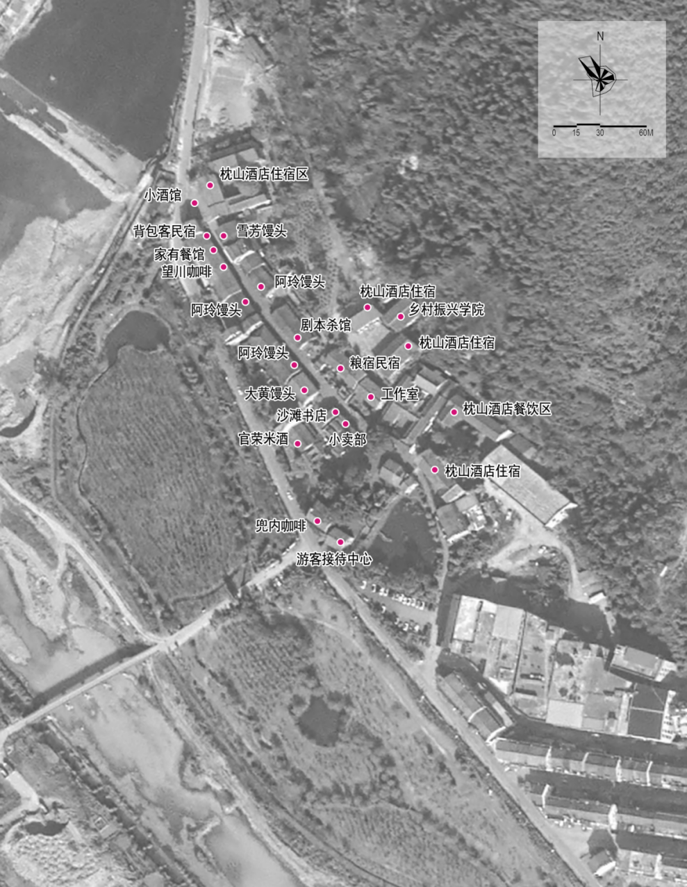

Figure 3 Spatial Distribution of Projects in Shatang Village

An analysis of residential population dynamics and built environment utilization efficiency reveals that over the past decade, despite the persistent decline in permanent residents due to urbanization, the functional efficiency of built spaces has paradoxically increased. This inverse evolution of population-space efficiency challenges traditional coupling models, which posit a linear correlation between population size and spatial utilization—where population shrinkage should theoretically reduce efficiency. Field investigations, however, demonstrate that through functional repurposing and spatial reproduction of vacant rural dwellings, traditional residences have been transformed into hybrid-use spaces, including cultural exhibition halls, maker workshops, and homestay clusters. These interventions have significantly enhanced the frequency of use and service capacity per unit of built space. Consequently, this “inverse revitalization” scenario aligns more closely with the residential population-built space efficiency coupling model proposed in this study.

### **3.2.3 Analysis of Efficiency Coupling Mechanisms in Shatang Village**

**（1）Companion-Style Planning**

Since 2013, the Tongji University Huangyan Rural Planning team has formulated and implemented the Beautiful Village Plan for Shatang Village. By systematically assessing the distribution patterns and structural conditions of underutilized public facilities, the plan strategically integrates future village development with the adaptive reuse of existing infrastructure, anticipating new functional demands under evolving urban-rural dynamics.

Over a decade of implementation, the village has acquired new socioeconomic roles while preserving its original spatial texture and architectural heritage. Eight vacant public facilities in the Old Street Block—all constructed during the People’s Commune era (1960s–1980s)—have been revitalized and repurposed (Figure 4). For instance, a disused grain storage station was transformed into a homestay, a derelict veterinary station became a tourist service center, and an abandoned township administrative building was converted into a boutique hotel. This approach balances preservation and adaptation, retaining the village’s historical memory while revitalizing its physical fabric. Such interventions not only safeguard cultural continuity but also create spatial prerequisites for attracting new demographics and economic activities.

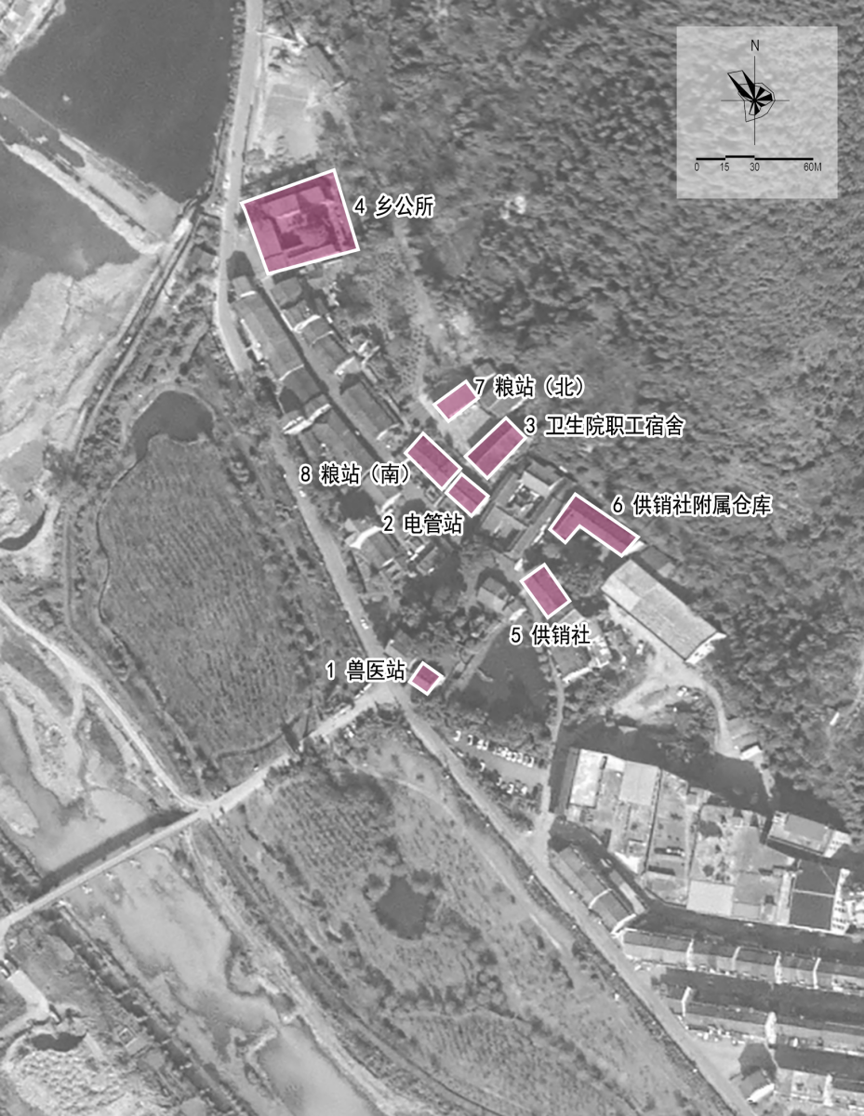

Figure 4 Adaptive Reuse of Existing Assets in Shatang Village

**（2） Multi-Actor Collaborative Placemaking**

During the initial phase of revitalizing Shatang Old Street, the absence of both tourists and commercial tenants posed a significant challenge. Following deliberations between village cadres and resident representatives, a bold policy was enacted: three years of rent-free occupancy for businesses operating on the Old Street. This incentive attracted local enterprises such as A’ling Steamed Buns and Xiaoya Rice Cake shops, alongside external businesses including Dounai Coffee, Grain Lodge Homestay, and Yuguang Bar. Their establishment filled critical gaps in the street’s commercial ecosystem, while the steady influx of visitors generated robust revenue streams, transforming these venues into social media hotspots.

Notably, Dounai Coffee—an unremarkable rural residence in early 2024—was revitalized in April through collaborative efforts by the Huangyan District Youth League Committee, Huangyan Young Entrepreneurs Association, and the Wenyi Society team. Leveraging platforms like Xiaohongshu and Weibo, the café achieved over one million online impressions (Figure 5), drawing nearly 1,000 young visitors. Its innovative operational model has injected vitality into rural revitalization, with daily coffee sales exceeding 100 cups during peak holidays (e.g., Labor Day, National Day). Collaborations with local heritage brands like Da Huang Steamed Buns have created hybrid “coffee + local culture” consumption experiences. Concurrently, the Yutou Has Light | Youth in the Village sustainable rural art festival (Figures 7, 8) has attracted over 100 young artists nationwide, fostering the Rural Art Creation Officer residency program.

Huang Kunpeng, founder of Da Huang Steamed Buns, transitioned from the competitive e-commerce sector in 2024 to explore opportunities in his hometown. Starting with no prior experience, he apprenticed under local artisans to master traditional bun-making techniques. Struggling initially with distribution, he pivoted to social media marketing, posting short videos on Xiaohongshu to amplify brand visibility (Figure 6). His account now boasts 19,000 followers and 98,000 likes, driving a surge in orders. To meet demand, Huang recruited over 10 villagers, structuring operations into three specialized divisions—digital marketing, sales, and production—to optimize efficiency under a novel business model.

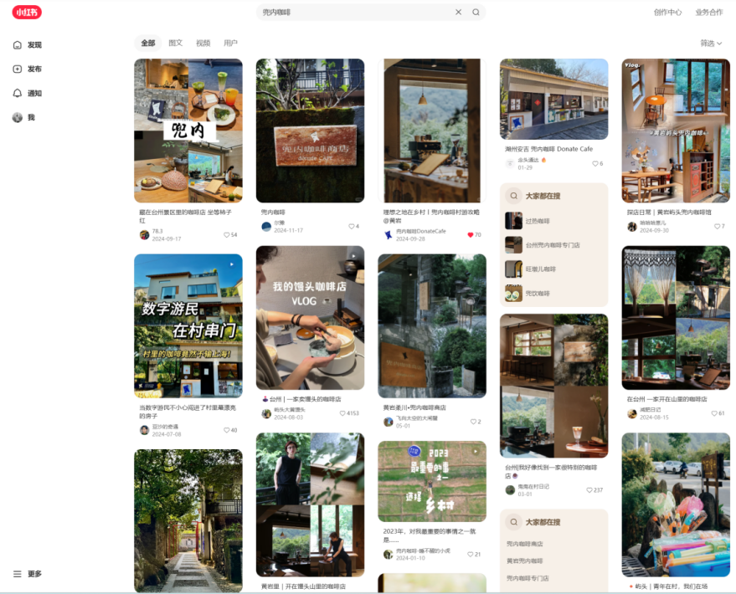

Figure 5 Interface Display of Dounai Coffee’s Xiaohongshu Account

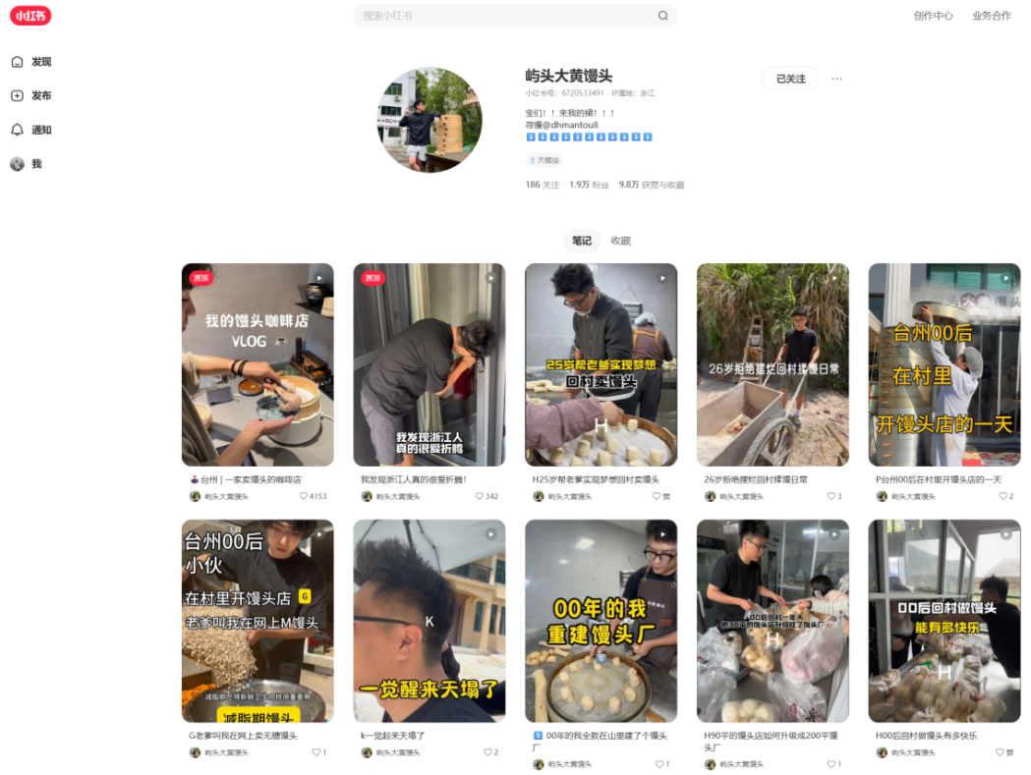

Figure 6 Page Display of Da Huang Steamed Buns’ Xiaohongshu Account



Figure 7 Recruitment for the 2024 Inaugural Youth in the Village Sustainable Art Festival



Figure 8 Recruitment for the 2025 Shatang Village Youth Art Season

Further analysis delves into the tripartite actors influencing the “resident population–built space efficiency coupling” in Shatang Village—original inhabitants, returning migrants, and new migrants—and their evolving complementary synergies.

Original inhabitants, as core nodes of the rural social network, not only serve as inheritors of traditional lifestyles but also effectively express governance agency through participation in collective decision-making mechanisms. Their place-based knowledge ensures cultural compatibility in spatial transformations, exemplified by their role as cultural gatekeepers in architectural style preservation and public space layout. Returning migrants, leveraging cross-regional social capital and modern management concepts, act as bridges for bidirectional urban-rural resource flows. By introducing external market resources through entrepreneurial ventures in homestays and cultural industries, this group generates demonstration effects. Their dual identity mitigates conflicts between external capital and local culture. New migrants, as carriers of heterogeneous innovation, drive functional upgrades in traditional spaces by introducing urban consumption cultures and new economic formats. Their professional expertise in artistic interventions and brand marketing significantly enhances the market recognition of rural spaces, injecting innovation momentum into community development through their external characteristics.

The interaction mechanisms among these multiple actors exhibit distinct spatiotemporal evolutionary characteristics. During the initial stage of spatial reproduction, policy-guided resource aggregation formed a primary commercial ecosystem. As social networks between actors deepened, this evolved into a value co-creation model anchored in cultural identity. Specific synergies include: the complementary relationship between original inhabitants’ spatial usage rights and new migrants’ operational management; returning migrants’ social capital reducing transaction costs; and the continuous influx of consumer groups reinforcing positive feedback mechanisms in spatial reproduction. Notably, the role boundaries among the three actors in spatial practices demonstrate a dynamic blurring trend. This deepening intersubjectivity facilitates a transformation from the traditional "host-guest dichotomy" to a symbiotic network.

**References**

[1] Brenner, N. , & Schmid, C. . (2011). Planetary Urbanisation.

[2] World Cities Report 2022: Envisaging the Future of Human Settlements, 2022, United Nations Human Settlements Programme ( UN-HABITAT)

[3] Gobillon, L. , Selod, H. , & Zenou, Y. . (2003). Spatial mismatch: from the hypothesis to the theories. Social Science Electronic Publishing.

[4] Studies, R. , & Science, R. . (2024). Properly addressing rural shrinking? Overview of territorially unbalanced support programmes in Spain.

[5] Schubert, C. . (2018). Civil Society, Social Innovations and the Coping with Demographic Change. Three Case Studies of German Shrinking Rural Communities.

[6] Kaufman, C. N. . (2017). A Shrinking Rural Population and the Future of the American Political and Economic Systems.. (Doctoral dissertation, Purdue University.).

[7] Tian, Y. (2016). Village Social Atomization and Countermeasures Under Rural Depopulation: A Case Study of Japan. New Horizons, (6), 6.

[8] Woods, M. . (2011). Winning and losing: The changing geography of Europe's rural areas.

[9] National Bureau of Statistics of China. 2021

[10] Zhu, B., Li, H., Hu, Z., Wen, Y., & Che, J. (2022). An Evaluation and Optimization of the Spatial Pattern of County Rural Settlements: A Case Study of Changshu City in the Yangtze River Delta, China. Land, 11(9), 1412. https://doi.org/10.3390/land11091412

[11] Lefebvre,.H.(1984).The_production_of_space

[12] Zhang, M. . (2025). Branding process of cultural heritage in the context of rural revitalization in china: a case study of qingtian county. International Journal of Anthropology & Ethnology, 9(1).

[13] Brenner, N. . (2008). Globalisation as reterritorialisation: the re-scaling of urban governance in the european union. Urban Planning International, 36(3), 431-451.

[14] Yunqi Guo,Limin Jiao,Yujie Sun,Haoran Zhang,Zejin Liu & Gang Xu.(2024).A novel urban population-land coupling simulation model: Integrating spatial equilibrium and macro-micro strategies.International Journal of Applied Earth Observation and Geoinformation,132,104002-104002.

[15] Smith, D. P. . (2010). Extending the temporal and spatial limits of gentrification: a research agenda for population geographers. International Journal of Population Geography, 8.

[16] Smith, N. . (2002). New globalism, new urbanism: gentrification as global urban strategy. Antipode, 34(3).

[17] Gosnell, H. , & Abrams, J. . (2011). Amenity migration: diverse conceptualizations of drivers, socioeconomic dimensions, and emerging challenges. GeoJournal, 76(4), 303-322.

[18] Zhou, L. , Vries, W. T. D. , Guo, G. , Gao, F. , & Fang, C. . (2024). The effectiveness of voluntary collective action in china's rural land development. Habitat International, 150(000), 15.

[19] Hollander, J. B. (2018). A Research Agenda for Shrinking Cities. Cheltenham/Northampton, MA: Edward Elgar Publishing.

[20] Huangyan District Bureau of Statistics, Zhejiang. (2021). 2020 Seventh National Population Census Major Data Bulletin of Huangyan District [Government report]. Retrieved May 20, 2021, from https://www.zjhy.gov.cn/art/2021/5/20/art_1229516970_59026256.html

[21] Huangyan News Network. (2023, August 17). Innovative Practice of the "Joint Wealth Consortium" Model in Rural Revitalization [News report]. Retrieved August 17, 2023, from <https://hynews.zjol.com.cn/hynews/system/2023/08/17/034312710.shtml>

**Acknowledgements**

Supported by the National Natural Science Foundation of China (NSFC) General Program: Research on the Spatial Differentiation Mechanism and Planning Regulation of Rural Settlements - A Case Study of Zhejiang Region. Project Approval Number: 52378067. Execution period: April 1, 2022 - December 27, 2023