Research on Demand-Side Oriented Spatial Governance in Innovation Districts: A Case Study of Hangzhou West Sci-Tech- Innovation Corridor

Author’s Name: LU Chenyan1，HUANG Yi1*

Affiliation: 1Tongji University, China

*Email：huangyi@tongji.edu.cn

**Abstract (up to 125 words)**

To address global competition and economic transition, the development of innovation districts necessitates an urgent shift from a supply-side to a demand-side orientation. This shift implies that the "bottom-up" practical demands should be given due attention. This paper identifies entrepreneurs and employees, the key practitioners in the spatial production of innovation districts, as the parameters for effective demand. Using the Hangzhou West Science & Technology Innovation Corridor as a case study, this paper conducts in-depth fieldwork, surveys, and interviews. By thoroughly analyzing and understanding their characteristics, spatial needs, and the inadequacies of current regional supplies, the study proposes strategies for sustainable planning and governance of innovation districts based on these findings.

**1 The development needs of the innovation districts shifting to the "demand side"**

Since the reform and opening-up policy in1978, China's rapid industrialization and urbanization have fueled the construction of industrial zones. Local governments have adopted a cycle of large-scale new city (district) planning, land development, industrial and real estate investment, land financing, and new development projects, leading to the formation of various industrial zones, development zones, science and technology parks, and new cities. In response to the uncertainties in the global economic system since the 21st century and the transform demands between old and new economic drivers domestically, China's existing industrial zones or new districts have begun to transition from a "large-scale infrastructure + real estate" model to a "technological innovation + digital economy" model. Driven by policy incentives, a multitude of innovation districts have emerged, shaping diverse innovation spatial forms such as technology corridors, future science and technology cities, Characteristic Towns, maker spaces, and smart valleys. These innovative spatial forms not only provide a vast stage for industrial innovation but also inject new vitality into economic transformation and upgrading.

However, despite the remarkable achievements in the construction of innovation zones, the supply-oriented land development model still faces multiple challenges, including mismatch between the supply and demand of spatial products [1], inefficient resource allocation [2], imbalance between industrial and urban relations as well as jobs-residence relations [3], inadequate bearing capacity of public facilities, and spatial segregation [4]-[7]. Against this backdrop, the development of innovation zones urgently needs to shift from the supply side to the demand side to better accommodate the demands of the new economy. Specifically, this shift implies the need for effective demand measurement and planning guidance, that is, focusing on the genuine user demands within innovation districts and adjusting spatial supply and governance to meet the requirements of technological innovation and industrial transformation. Therefore, this paper takes entrepreneurs and employees in innovation districts as the practitioners of spatial production and regards them as parameters for effective demand. By exploring their characteristics and spatial demands, this paper explores spatial governance strategies for innovation districts, which holds certain contemporary significance and academic value for the planning and research of innovation districts.

**2 Innovation District Spatial Governance Approach: People-Oriented and Demand-Driven**

The concept of "the production of space" was first proposed by French sociologist Henri Lefebvre in 1974 [8]. He interpreted space as the fundamental organizational form of all human social production and practical activities, encompassing three dimensions: "spatial practice," "representations of space," and "spaces of representation." Space is "(social) space as a (social) product," and "each epoch produces its own space" [8]. Since then, scholars such as Manuel Castells, David Harvey, and Edward Soja have linked space to society, history, and social actors from the perspectives of the network society, space of flows, spatial capital, and spatial justice. They regard humans as the practical subjects of space and interpret the dynamic mechanisms of spatial development in urban or rural areas through the "dialectics" of space [9]-[12].

Led by Lefebvre, the theory of spatial production breaks through the "container" perspective of space. The manifestation of space is not merely seen as an objective entity but as a system of spatial production and relational reconstruction by social actors. Spatial entities continuously develop and change through purposeful human practices, thereby forming conceptualized abstract spaces. Society operates through space, and the boundaries of groups, along with their social power relations, are embedded and embodied in specific spatial structures [13]. In other words, space interacts with behavior, and each acting subject interprets and expresses their understanding and utilization of space through their practical activities in space, thereby constructing a unique and meaningful space.

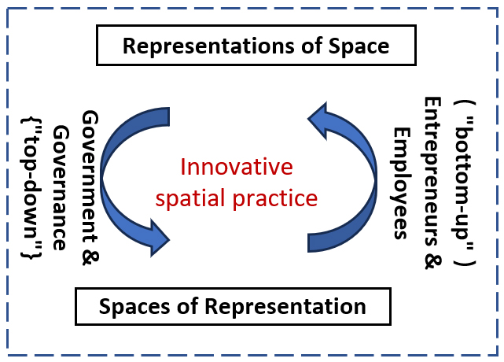

**Figure1: Spatial Production Analysis**

**(Drawn by the Author)**

From the perspective of spatial production, the spatial practice in innovation districts is a process of actors' (i.e., governments, entrepreneurs, and employees) practices and the reconfiguration of their relationships within regional spaces. As the spatial suppler in innovation districts, the government proactively recalibrates land use configurations, spatial provisions, and managerial support frameworks through integrated planning, development, and construction initiatives. This macro-level intervention crystallizes the "representations of space"—manifesting as the government's strategic vision for innovation district development.

Concurrently, entrepreneurs and employees on meso-micro level, functioning as demand-side spatial users, construct the "spaces of representation" through innumerable location-choosing and career-seeking activities with industrial development trends and personalized needs. These real demands behind these spatial representations serve as the direction for the adjustment of innovation districts. The dialectical interaction between supply-side interventions and demand-side responses constitutes the core mechanism of spatial practice within innovation districts (Figure 1).

In light of this, this study investigates the genuine spatial demands from entrepreneurs and employees within innovation districts, and basing on the existing space supply background, it proposes a holistic methodology for spatial development adjustment. Taking the Hangzhou West City Sci-Tech Innovation Corridor as a case study, through a mixed methods investigation of corridor-based practitioners—including enterprise’ organizational growth aspirations and employees’ occupational and personal requirements—the study establishes a demand-based framework for spatial supply and governance in innovation districts. This framework informs spatial strategies to align physical environments with the dynamic needs of innovation ecosystems, ensuring sustainable and inclusive development of innovation districts.

**2.1 Individual characteristics and types subdivision of practitioners**

Entrepreneurs and employees, serving as the key practitioners driving spatial production of innovation districts, continuously mold the region's spaces of representation through their actions. This spatial environment is profoundly imbued with the distinct characteristics of these practitioners, encompassing their personal experiences, value, production methodologies and lifestyles. These elements seamlessly integrate into the regional cultural, exerting a far-reaching influence on the cultural ethos of the local entrepreneurial ecosystem. They further shape entrepreneurial activities by establishing acceptable entrepreneurial practices and norms [14].

At the level of physical space, the industry choices of entrepreneurs and their establishment (or " selecting location ") directly impact the composition of the regional industrial landscape. Similarly, the occupational preferences and mobility patterns of employees are intricately intertwined with the region's spatial structure.

Consequently, this study from the perspectives of people-oriented and demand-driven, initiates its inquiry by examining the individual characteristics and categorizations of the region's practitioners，by focusing on the interconnections between the practitioners and the spatial production, sociocultural dynamics, economic growth trajectories, and value orientations of innovation district. It offers insights for a profound understanding of the spatial production within innovation districts.

**2.2 Entrepreneurship and Spatial Representation Characteristics**

Innovation districts function as a spatial carrier for government-led industrial innovation and clustering, reflecting the government's vision regarding industrial spatial layout. The ultimate realization of this planning vision hinges on the enterprises established by entrepreneurs, meaning that the location choices made by enterprises directly shape the actual configuration of industrial space within the innovation district. The process of enterprise location selection adheres to the "principle of maximum satisfaction" [15], being influenced by numerous factors such as the personal preferences of decision-makers (entrepreneurs), costs, market dynamics, labor availability, the socio-political environment, and the natural environment. It is a "bottom-up" process, and companies with different levels of development have different needs. Drawing on previous entrepreneurial research [16] [17], this paper classifies entrepreneurial enterprises into four categories: start-ups (established within 42 months), growth-stage enterprises (established between 42 months and 8 years), mature enterprises (established for over 8 years), and declining enterprises (determined based on the firm's specific circumstances) (as shown in Table 1). From the dimensions of entrepreneurial needs, motivations, modes of innovation, spatial preferences, organizational inclinations, and practical requirements, this study conducts an in-depth exploration of the spatial demands and representative features of industrial development within the innovation districts.

**Table 1 Classification of Entrepreneurial Enterprise Cycles (Source: Drawn by the Authors)**

|  |  |  |  |
| --- | --- | --- | --- |
| Stage | Definition | Classification Criteria | Main Characteristics |
| Start-up Enterprises | The stage where enterprises newly enter the market seeking survival | Within 42 months of establishment | Facing issues such as resource scarcity, market instability, information asymmetry, etc., known as "new entry defects," with a high mortality rate |
| growth-stage Enterprises | The rapid development stage of enterprises | 42 months to 8 years after establishment | Enterprises gradually stabilize in the market, their products begin to be accepted by customers, and their organization and scale grow, integrating into the industrial ecosystem |
| Mature Enterprises | The stage where enterprises expand to have a certain degree of market discourse power | Over 8 years after establishment | Having market influence, stable operations, sound industrial mechanisms, and typically occupying key links in the industrial ecosystem |
| Declining Enterprises | The period when enterprises enter a stage of decline or weakness in development | Judged based on the enterprise's own situation | Due to market saturation, product substitution, or management rigidity, they often maintain the status quo and need to restructure industrial relations to prevent decline |

**2.3 Employment and Spatial Representation Characteristics**

Employees are not only crucial participants in the regional industrial economy but also significant shapers of the regional spatial landscape. While the regional industrial structure selects employees, it is simultaneously influenced by their occupational choices and mobility. This interactive dynamic further impacts the development of regional production and living facilities, as well as other functional aspects such as commerce, leisure, and residential areas. From the perspective of employment development, this study explores the demands and representation characteristics of industrial spaces, various supporting facilities, and spatial configurations within innovation districts by examining the considerations of employees in terms of career choice, location selection factors, spatial preferences, and resource inclinations.

Based on the exploration of the individual characteristics of the practitioners (entrepreneurs and employees) in regional representation spaces and the factors behind their spatial location choices, this study discusses spatial governance strategies for innovation districts. Taking the Hangzhou West Science and Technology Innovation Corridor (referred to as the Grand Corridor) as an example, questionnaires were distributed and over 60 open-ended interviews were conducted with practitioners of the innovation district. The questionnaires were disseminated via WeChat, and individuals outside the Grand Corridor were excluded based on IP addresses. A total of 158 questionnaires from entrepreneurs and 171 from employs were collected, totaling 329 valid questionnaires. The questionnaire respondents comprehensively covered the main industries in the Grand Corridor, and the industry distribution closely aligned with the regional industrial pattern, demonstrating good reliability (Figure 2). Based on this data, the paper proceeds with its analysis.

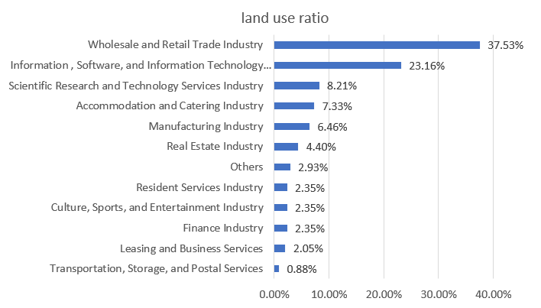

**Figure 2: Industry Distribution of 329 Enterprises (Source: Questionnaire Survey)**

**3 "People-Oriented" Spatial Representation Characteristics in Innovation Districts: A Case Study of the Hangzhou West Science and Technology Innovation Corridor**

The Hangzhou West Science and Technology Innovation Corridor (referred to as the Grand Corridor) originated from the West Science and Technology Industry Cluster Zone which is established in 2009.It was the only cluster zone focusing on science and technology innovation among Zhejiang Province's 15 industrial cluster zones. At the end of 2015, it was officially renamed as the Grand Corridor, as a key development zone by Zhejiang Province and Hangzhou City for promoting economic transformation and upgrading .Situated in the western part of Hangzhou City, Zhejiang Province, the Grand Corridor spans from Zijingang Campus of Zhejiang University in the east, to Zhejiang Agriculture and Forestry University in the west, encompassing numerous universities and research institutions. According to the "The 14th Five-Year Plan for the Development of Hangzhou Chengxi Science and Technology Innovation Corridor (2021)" planning , the Grand Corridor covers a total area of 416 square kilometers (Figure 3).

As outlined in "The 14th Five-Year Plan for the Development of Hangzhou Chengxi Sci-Tech Innovation Corridor (2021)", the Grand Corridor's planning vision (presentations of space) aims to establish a globally leading digital science and technology innovation center, a leading area for high-quality development, a pioneer area for urban modernization, and a demonstration area for integrated intelligent governance. It seeks to initially construct an innovation source that embraces the world, leads the future, serves the nation, and propels the entire province (Figure 4).

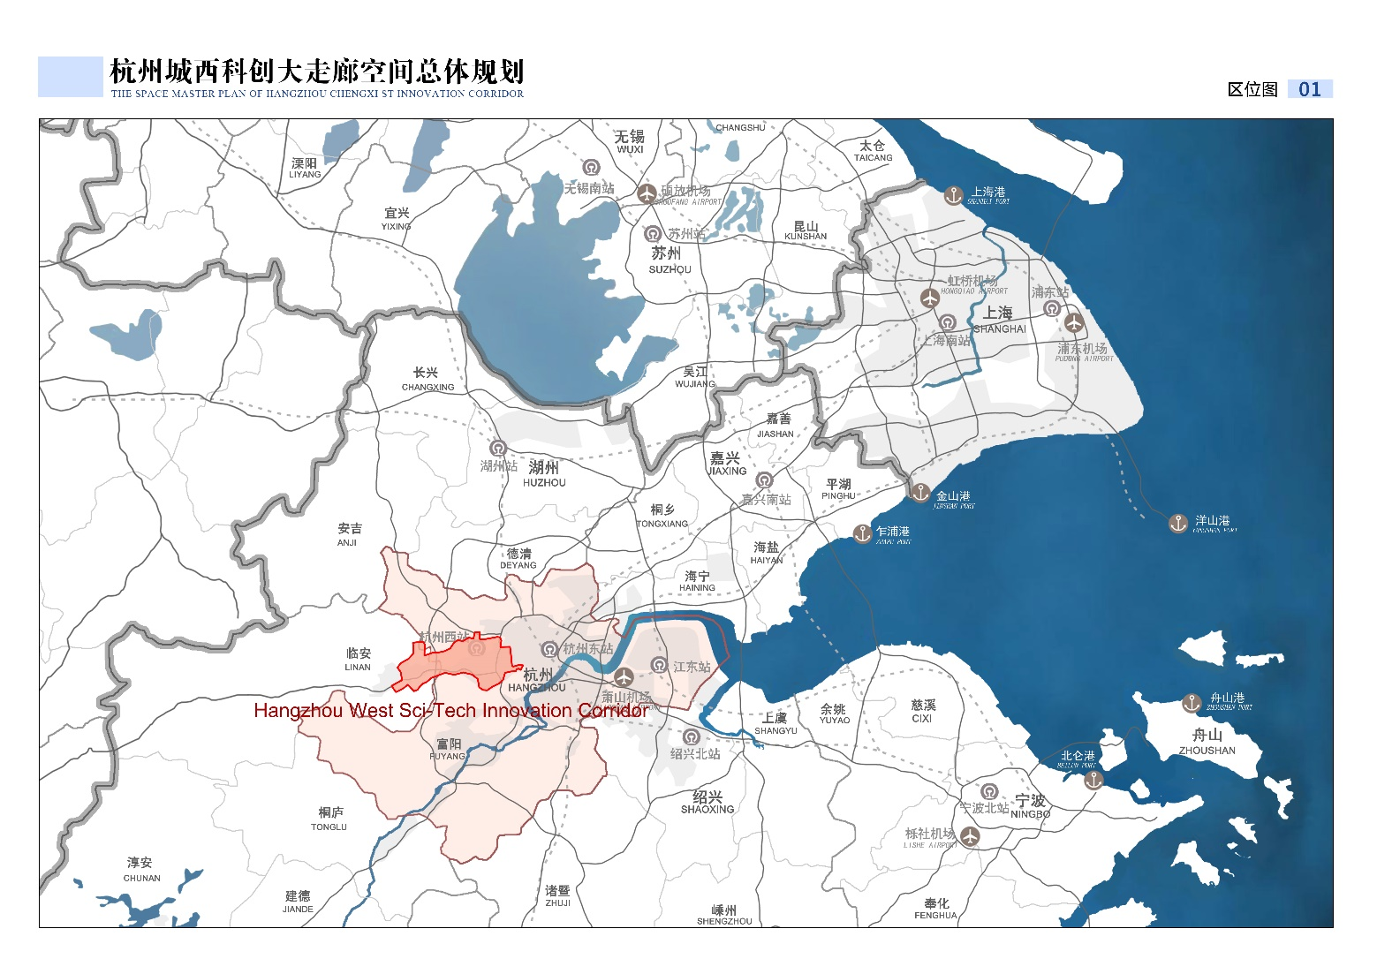

**Figure 3. Location Map of the Hangzhou West Science and Technology Innovation Corridor**

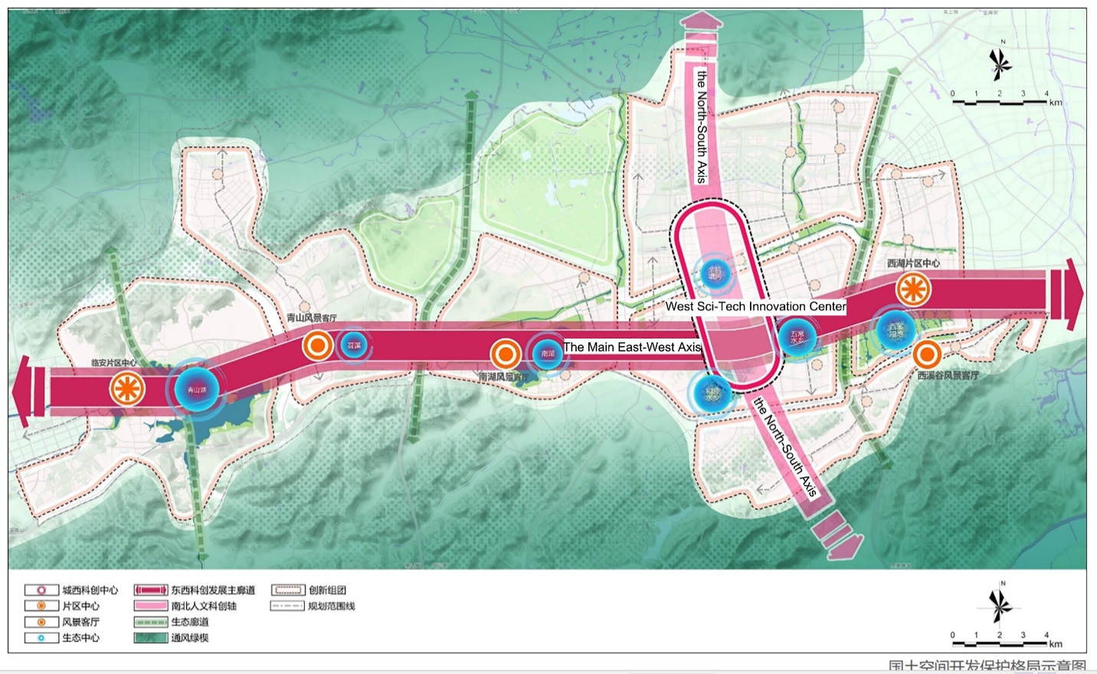

**Figure 4: Schematic Diagram of the Corridor's Development Layout (Source: The 14th Five-Year Plan for the Development of Hangzhou Chengxi Sci-Tech Innovation Corridor)**

**3.1 Characteristics of the Practitioners in the Grand Corridor**

Survey findings reveal distinct characteristics of the practitioners of the Grand Corridor. Entrepreneurs are predominantly male (62.66%), with individuals aged 26-35 constituting the main entrepreneurial force (50.63%). Furthermore, a significant majority of entrepreneurs possess at least a bachelor's degree (80.38%)，and extensive work experience（with 61.4% having more than 5 years of work experience）. Among employees, females account for a slightly higher proportion（54.97%）than males, with the "18-25" and "26-35" age groups making up 75.44%. The educational background is predominantly bachelor's degree or above, with a relatively balanced distribution of work experience years, reflecting the stable mobility of employees in the region. Both entrepreneurs and employees predominantly originate locally, supplemented by inflows from outside the region. This indicates that entrepreneurs in the Grand Corridor generally exhibit individual traits of localization, youthfulness, high educational attainment, and substantial work experience, while employees demonstrate localization, youthfulness, high educational attainment, and stable mobility (Figures 5-12 and Tables 2-3).

**Table 2: Survey on the Channels Through Which Entrepreneurs in the Region Came to Hangzhou**

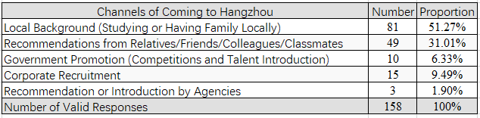

**F5: Gender Ratio of Entrepreneurs**; **F6: Gender Ratio of Employees 6**; **F13: Entrepreneurial Initiative**

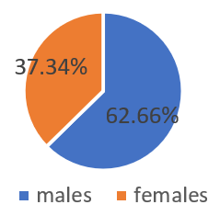 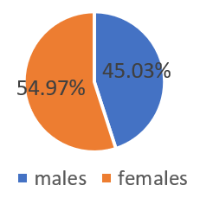 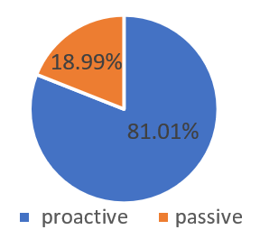

**F7: Age Distribution of Entrepreneurs F8: Educational Background Composition of Entrepreneurs**

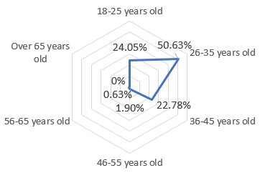 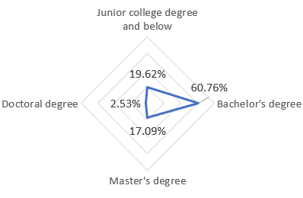

**F9: Work Experience Duration of Entrepreneurs in the Region** **(Source: Questionnaire surveys)**

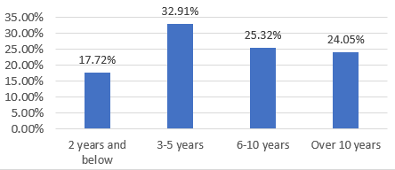

The Grand Corridor boasts a high proportion of "proactive" entrepreneurs (81.1%), in contrast to a mere 18.9% of passive entrepreneurs (Figure 13). Not only do entrepreneurs acknowledge the entrepreneurial opportunities available in Hangzhou, but a substantial portion of employees also harbor aspirations for entrepreneurship. Among interviewed entrepreneurs (Table 3), over 60% report having "many acquaintances who are entrepreneurs." Similarly, among interviewed employees (Table 5), nearly half perceive "many individuals around them as entrepreneurs," with only 39.18% preferring stable employment, whereas 26.9% express a willingness to "attempt entrepreneurship if given the opportunity." Almost one out of four employees could be a potential entrepreneur. The local populace has a strong sense of initiative in entrepreneurship, and the region is imbued with a robust entrepreneurial action attribute.

**Table 3: Survey on the Channels Through Which Employees in the Region Came to Hangzhou**

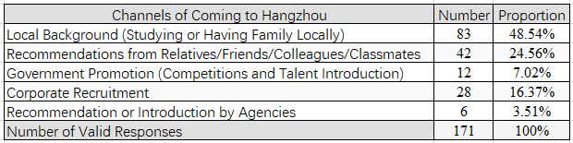

**Table 4:** **Entrepreneurial Cognition Measurement: Entrepreneurs**

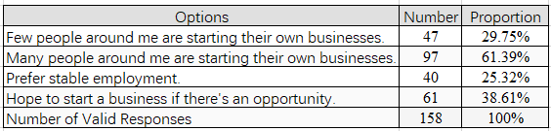

**Table 5: Entrepreneurial Cognition Measurement: Employees**

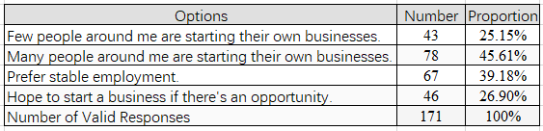

**F10: Age Distribution of Employees F11: Educational Background Composition of Employees**

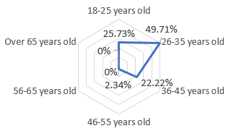 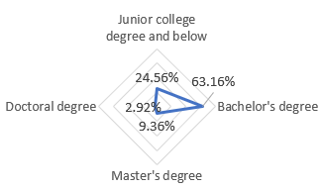

**F12: Work Experience Duration of Employees in the Region (Source: Questionnaire surveys)**

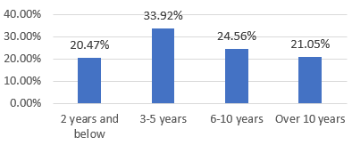

This phenomenon may be attributed to the region's long-standing tradition of valuing commerce, which can be traced back to the Spring and Autumn Period in the history, exemplified by the era of "Business Saint" Fan Li. Over time, the practice of valuing both culture and commerce has cultivated a cultural tradition that "values commerce and technology" and "considers industry and commerce as foundational," alongside a behavioral pattern characterized by "pragmatism" and "daring to innovate." Consequently, the local populace has developed a distinct preference for risk, with more prominent business opportunity capture capabilities and risk tolerance, thereby fueling widespread entrepreneurial and innovative endeavors within the region.

**3.2 Entrepreneurship and Its Spatial Representation**

This study delves into the industrial space of innovation districts that is selected and constructed by the entrepreneurial cohort, through the perception of entrepreneurs. From the perspective of entrepreneurial motivation, "identifying good business opportunities" stands out as the primary driving force for entrepreneurs in the Grand Corridor, followed by "increasing wealth," "achieving self-worth," and "pursuing freedom." The proportion of those who start businesses due to "being unable to continue with their current jobs" is the lowest (Figure 14). This indicates that entrepreneurs in the region are relatively proactive in their ventures, with most being motivated by business opportunities and a keen sense of market trends, thus belong to proactive entrepreneurship.

In terms of innovation, while establishing new brands, the region entrepreneurs place equal emphasis on multiple innovation models (Figure 15). Innovation is significantly influenced by the product market. The largest proportion of research and development (R&D) activities are driven by "customer requirements" and "dealer market reports," followed by internally generated ideas. Self-directed R&D is the main approach, with a certain demand for external collaborative innovation (Figures 16 and 17).

From the perspectives of resource demands and spatial choices, entrepreneurs exhibit distinct needs at different stages of their ventures, generally leveraging existing social connections or resource networks. During the start-up phase, most enterprises have fewer than 10 employees, affording a relatively small scale (Table 6). Beyond self-funded capital, "family members,", "friends and relatives,", and "colleagues" emerge as the primary and most immediate sources of financial support for startups, predominantly sourced through the entrepreneurs' personal resource pools and network ties (Figure 18). Consequently, startups prioritize "preferential policies and financial support" as the most crucial factor, followed by "low costs for pilot-scale production and processing" and "low office rental costs." This prioritization is linked to the exploratory and uncertain nature of products during the startup phase, which necessitates continuous capital infusion (Figure 19).

**Figure 14: Survey on Entrepreneurial Motivations of Entrepreneurs in the Region**

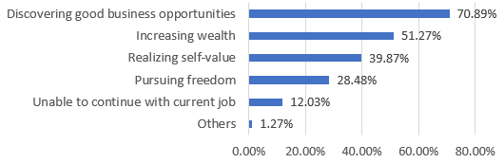

**Figure 15: Ranking of the Proportion of Enterprise R&D Types**

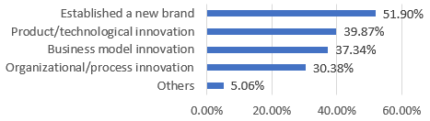

**F16: Importance Analysis of Innovation Idea Sources F17: Survey on Innovation Models**

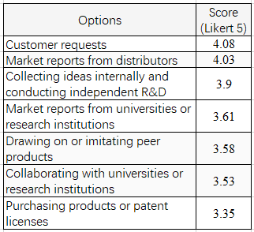 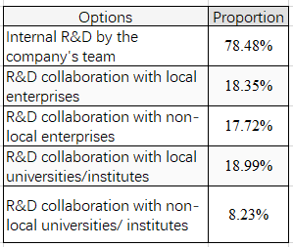

**Table 6: Proportion of Employee Size at Different Business Development Stages (Source: All from Questionnaire Survey)**

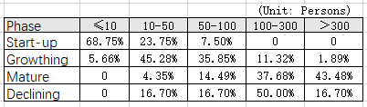

In terms of location selection (Figure 20), the "favorable atmosphere for innovation and entrepreneurship" in the Grand Corridor is a significant influencing factor for startups choosing to establish themselves there, with a satisfaction rating of 4.17. This is closely followed by "attractive preferential policies and incentives" (4.12), "proximity to relevant industrial clusters" (4.11), and "convenient transportation and facilities" (4.09). Other factors, such as "a beautiful urban environment", "abundant human resources", and "proximity to customers or suppliers", also play a role. Evidently, when considering the cost expenditures and opportunities associated with setting up a business, entrepreneurs often opt for regions with a vibrant entrepreneurial atmosphere and access to preferential policies. They also take into account costs related to transportation and facilities, preferring areas with convenient transportation and well-developed public infrastructure.

**F18: Scoring of Funding Sources for Enterprises at Different Stages (Rating Scale: 1-5)**

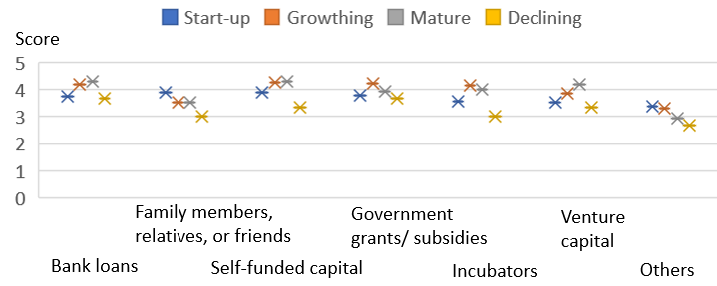

Hence, when it comes to specific spatial selections (Figure 21), startups exhibit a preference for "small but excellent" spaces. The option of "characteristic courtyard spaces" garners the highest preference rate among startups (44.38%), closely followed by "shared workstations with complete facilities" (41.25%) and "technology parks that match their professional fields" (41.25%). These choices underscore the startups' quest for comprehensive entrepreneurial support facilities while keeping costs low. However, field research has revealed that "small yet exquisite" spaces favored by startups, such as Dream Town, often come with high entry barriers and insufficient supply. As a result, more startups can only be located in surrounding villages and towns, collective land, old factories, and other areas with low rent and close to intellectual density and convenient transportation. In choosing their locations, startups prioritize convenience within the framework of economic affordability.

The resource requirements of enterprises in the growth stage significantly differ from those of startups (Figure 19). The growth-stage enterprises prioritize "entrepreneurial services such as product promotion and patent applications," reflecting their urgent need to meet market production capacity demands. Subsequently, they emphasize "venture capital" and "preferential policies and financial support"," as capital remains a pivotal factor determining their ability to expand production and explore new markets. The office and pilot-scale production costs, which were once major considerations, are no longer primary focuses for these enterprises. From the perspective of funding sources (Figure 18), "incubators" are an important channel for growth-stage enterprises to obtain capital, which is closely related to the one-stop incubation services mainly provided by incubators in the Grand corridor. Incubators represent the primary avenue through which growth-stage enterprises can readily access funds and other resources. The following incubators, such as "government subsidies"," "self-financed capital"," and "bank loans" are also significant funding sources. "Family, relatives, or friends" have become less important as entrepreneurs expand their external channels and are no longer the main funding channels they rely on.

In terms of location selection (Figure 20), "favorable entrepreneurial policies" (84.44%) emerged as the most crucial factor for growth-stage enterprises when choosing to settle in the Grand Corridor. This was followed by factors such as "having a relevant industrial chain foundation" (82.89%), "abundance of relevant talents" (81.61%), "strong reputation and a favorable atmosphere for innovation and entrepreneurship" (81.19%), and "convenient technical support/R&D cooperation" (81.14%). Next in importance were "sufficient land for enterprise expansion and development" (79.02%) and "local background" (76.89%). It is evident that the growth-stage enterprises place greater emphasis on obtaining preferential funds, market access, and talent acquisition, which are essential for establishing a foothold in the market. Regarding specific spatial choices (Figure 21), the growth-stage enterprises prioritize spaces that offer growth and development potential in the future. As a result, comprehensive and high-quality science and technology parks are the preferred choice for these enterprises, followed by "modern large-floor-space premises" (39.62%) and "independent buildings" (38.68%).

Compared to other enterprises, mature enterprises pay more attention to industry prospects and new business opportunities (Figure 19). They rank "industry technology and information" and "entrepreneurial services such as product promotion and patent applications" as their top priorities, indicating their development needs to explore new growth points and maintain a leading position. In terms of accessing entrepreneurial funds (Figure 18), apart from profits generated from enterprise sales, "bank loans" and "venture capital" are important channels for them to obtain funds, followed by "incubators" and "government subsidies"." As enterprises grow, "self-funded capital" and "funds from family, relatives, or friends" become less significant. Mature enterprises have successfully established a resource network based on themselves, demonstrating strong anti-risk capabilities and smooth access to market-oriented investment and financing channels.

In terms of location selection (Figure 20), mature enterprises prioritize "abundant human resources" (4.22) and "sufficient development space/land" (4.19). This is followed by factors such as "proximity to customers or suppliers" (4.15), "attractive policy incentives and rewards" (4.12), and "having a local background" (4.08). Other factors include "a beautiful urban environment"," "a favorable atmosphere for innovation and entrepreneurship"," "convenient transportation and facilities"," and "proximity to industrial clusters"." It can be seen that considering their development scale and the ease of talent acquisition, entrepreneurs of mature enterprises tend to choose regions with relatively abundant human resources and surplus land. They also pay more attention to the overall technological foundation and knowledge level of the region. The mature enterprises surveyed in this study generally possess independent buildings or parks, indicating a certain degree of independence in their spatial location choices. Many enterprises have expressed a vision for later relocation and expansion, but they are cautious about new locations, preferring to move within the same region rather than deviating from existing human or resource channels. Their location selections are more proactive and prudent. Regarding specific spatial choices (Figure 21), mature enterprises prefer independent land use, favoring "independent buildings" (51.68%) and "modern large-floor-space premises" (49.13%). This is related to the expansion of their organizational structure and employee scale. To alleviate the sense of oppression brought about by their scale, mature enterprises place greater emphasis on the leisure and stress-relieving aspects of their internal office areas, paying more attention to the spiritual relief needs of public spaces, such as natural spaces.

**F19: Evaluation of Resource Needs for Enterprises at Different Stages** **(Rating Scale: 1-5)**

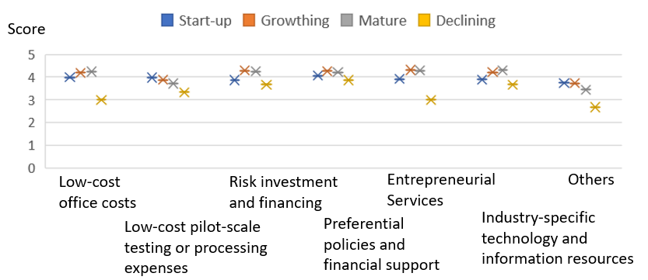

**F20: Evaluation of Location Selection Needs for Enterprises at Different Development Stages**

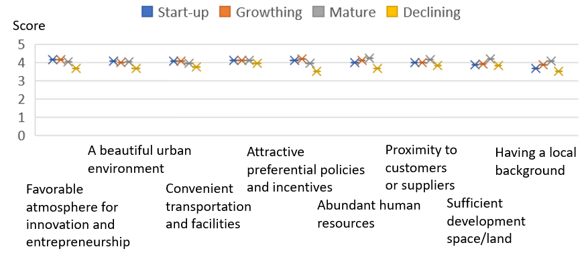

F**21: Analysis of Specific Spatial Choices for Enterprises at Different Development Stages**

**(Source: All from Questionnaire Survey))**

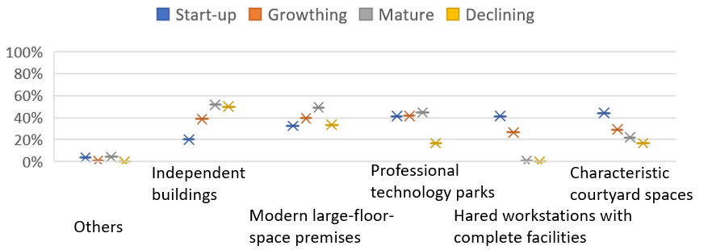

Decline enterprises are relatively limited in number, and thus their analysis primarily relies on interview data. Most of the decline-stage enterprises surveyed were established before the naming of the "Grand Corridor". These enterprises are predominantly from traditional manufacturing sectors such as electronics, electrical appliances, textiles, or and building materials. Due to the factors such as technological substitution, market renewal, and upgrades, they have progressively lost their competitive edge in the industry and are now at risk of being phased out. They harbor aspirations to develop new business ventures but are simultaneously apprehensive about the associated risks, leading to a lack of innovation drive.

Maintaining the status quo yields low profits and inadequate cash inflows. "Bank loans" and "government subsidies" are their main channels for obtaining external financial support, and their demand for innovation is significantly lower than that of enterprises in the other three stages. Consequently, in the evaluation of resource preferences, declining enterprises place the highest value on preferential policies and financial support. They also require external resources like industry-specific technological information and venture capital to facilitate industrial transformation or enhancement. However, their overall resource preference ratings are not high, suggesting limited internal initiative.

In terms of location selection, urban improvements and economic development have enhanced the appeal of their locations, resulting in an appreciation of enterprise land values. Nevertheless, most enterprises opt to increase the output value and corporate earnings of their existing lands by leasing or selling them, reflecting insufficient innovation momentum. They express hopes for policy-driven relocation or replacement processes but exhibit low proactivity in independently choosing new locations.

**3.3 Employment and Its Spatial Representation**

By examining the perceptions and job-selections of employees, we can understand the characteristics of the industrial spaces preferred by employees, as well as the representation of other functional spaces involved in their production and daily lives. From the perspective of job-selection motivations (Figure 22), respondents in the questionnaire ranked "salary" and "self-actualization" as their top two priorities, followed by "alignment with corporate culture", "personal interest", "promotion opportunities", and "commuting distance"." Next came "alignment with one's major" and "work environment". Employees in the Grand Corridor do not regard salary as their sole pursuit; instead, they place greater emphasis on realizing their own value and matching their individual spirits with enterprise. This reflects a high-level spiritual need among employees in the Grand Corridor to transcend salary pursuits and value the alignment between their own worth and that of the enterprise.

This spiritual pursuit is similarly manifested in considerations for job location selection. In open-ended interviews, the majority of employees deemed the Grand Corridor as their ideal employment area. Exploring the reasons behind this (Figure 23), "beautiful urban environment" emerged as the top factor, followed by "promising development prospects of the industry", "a large number of like-minded individuals"," and "high government efficiency"." Next were "well-developed public facilities", "convenient transportation", "strong foundation for cooperation and innovation"," and "preferential policies and incentives". Finally came "cost of living or work"." This reflects a characteristic among employees where they prioritize personal growth over cost considerations in employment, placing greater importance on regional environment, job prospects, and opportunities for their own development.

Specifically, these characteristics vary among employees of different age groups. Firstly, the motivations driving job location selection differ among age groups (Figure 25). The "18-25" age group places significantly higher emphasis on "convenient transportation", "well-developed public facilities", and "relatively low living or working costs" compared to other age groups. This can be attributed to their new entry into the job market, limited resource accumulation, and concerns about convenience and economic pressures. The "26-35" age group exhibits relatively balanced ratings across various factors, indicating a comprehensive and meticulous consideration of all aspects. The "36-45" age group places the utmost importance on "salary". Employees in this age bracket often serve as the primary financial providers for their families and hope to reflect their professional value and sense of accomplishment through higher salaries. The "46-55" age group prioritizes "the development prospects of the industry they belong to". Employees in this age range are typically in the later stages of their careers and place greater importance on industry stability and long-term development trends.

Secondly, the pursuit of innovative spirit also varies among age groups. The "36-45" age group has the highest proportion (31.58%) of employees who "feel that they have the opportunity to try entrepreneurship", followed by the "26-35" age group (28.24%). The "18-25" age group has the lowest proportion (22.73%) of those willing to attempt entrepreneurship. These differences result in distinct demands for the employment environment among different groups of employees.

Thirdly, the demands for regional spatial amenities also differ across age groups. Based on the survey of job environment satisfaction, employees within the Grand Corridor are generally quite satisfied with the existing employment environment. Those expressing "relatively satisfied" or "very satisfied" attitudes account for 66% of the total respondents, while only 5% hold "dissatisfied" or "very dissatisfied" views (Figure 24). Specifically, the "18-25" age group exhibits lower satisfaction levels with the surrounding transportation and public facilities, particularly noting a lack of diverse recreational and entertainment amenities. Employees in the "26-35" age group believe that the most pressing areas for improvement in their current industrial parks are external supporting facilities, followed by external transportation conditions and the availability of public transportation. Within the park，they express relatively high satisfaction with the spatial organization and indoor environmental quality of the enterprises they work for. They perceive the need for improvement primarily in "internal supporting facilities", particularly advocating for an increased supply of high-quality spaces and amenities for communication and leisure activities.

Both the "36-45" age group and those aged "46 and above" highly appreciate the cultural atmosphere and beautiful natural environment of the Grand Corridor. Nevertheless, they note a relative dearth of high-quality supporting facilities such as education, healthcare, and recreational amenities. In particular, the scarcity of high-quality educational facilities struggles to meet the expanding needs of families. This is also reflected in the interviews, where the majority of employees mention that the most urgent areas for improvement in the Grand Corridor are public facilities related to transportation, commerce, leisure, daily living, as well as communication spaces.

In terms of office space and facility usage within specific park, many employees have a high level of satisfaction with the internal and external environment, building appearance, building functions, and building space of the park or office building where they are currently employed (Figure 26). "Open-plan offices" and "flat organizational structures" are widely recognized and accepted forms of office organization among employees, who believe that these arrangements can effectively enhance office efficiency and facilitate collaborative efforts.

Public spaces focus on stress relief and relaxation, but the supply varies depending on the conditions of the enterprise (Figures 27 and 28). Start-up enterprises and declining enterprises prioritize basic needs in the use of public spaces, making the "dining area" the most popular space among startup personnel (30.63%). Growth-stage enterprises exhibit needs similar to those of start-ups, but there is a notable increase in the preference for natural spaces that aid in stress relief and tea-break areas for relaxation. In contrast, employees in mature enterprises show the strongest preference for "outdoor natural spaces" (31.88%), followed by "fitness and exercise areas" (23.19%), "dining areas" (20.29%), and "tea-break areas" (13.04%). This indicates a growing emphasis on the mental and emotional well-being aspects of public space utilization, a trend that gains prominence as enterprises expand in scale and enhance their capabilities.

**F22: Survey on Entrepreneurial Motivations F23: Importance Assessment of Location Selection**

**of Entrepreneurs in the Region Considerations for Employees in the Region**

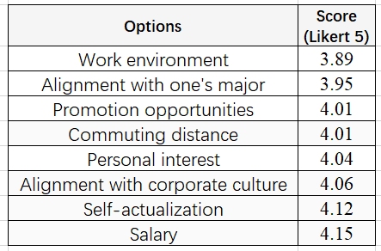 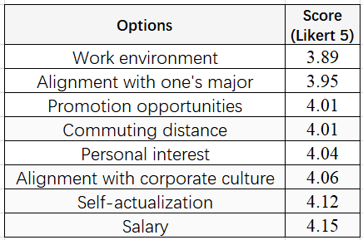

**F25: Job Selection Consideration Ratings for Employees in Different Age Groups in the Region**

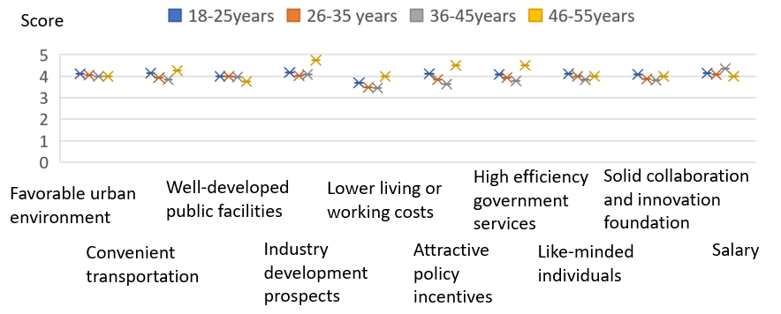

**F24 Satisfaction with the Employment Environment**  **F26 Regional Environment Evaluation**

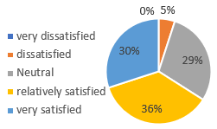 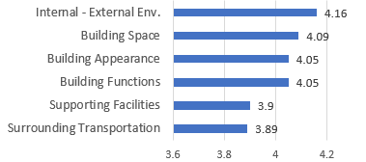

**F 27: Analysis of "Favorite Public Spaces" Among Employees at Different Career Stages**

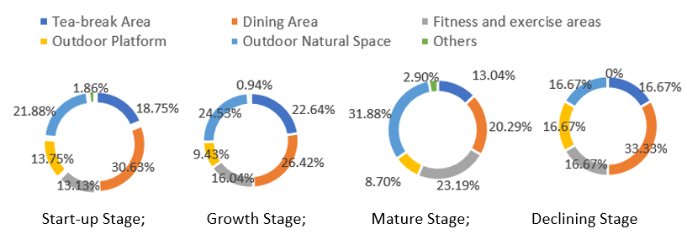

**Figure 28 Survey on the Reasons for Liking the Above-mentioned Public Spaces**

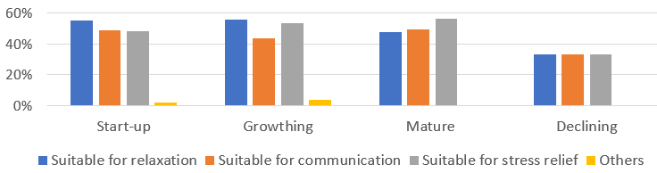

**4 Suggestions for "People-Oriented" Spatial Governance Strategies in Innovation Districts**

Based on the characteristics of the practitioners and the spatial representations of entrepreneurs and employed individuals within the Grand Corridor, this paper proposes "people-oriented" spatial governance strategies for innovation districts.

**4.1Overall-Level: Strengthening Regional Characteristics and Industrial Resources to Construct a "People-Centered" Spatial Governance Framework for Innovation Districts**

On one hand, anchored in the region's long-standing cultural tradition of "merchant-oriented" values and the population's inherent trait of "risk-taking spirit," we aim to establish the regional image of the "entrepreneurial and innovative haven "in the Grand Corridor, thereby mentally unifying the spatial governance approach of the innovation district. Through urban marketing strategies such as elite guidance, policy incentives, and case shaping, we can encourage or emphasize the region's innovativeness and inclusiveness, attracting innovators to settle down and fostering the emergence of entrepreneurs and employees.

On the other hand, we spatialize the perception of the image. Beginning with the spatial requirements of entrepreneurs and employees, we construct a "people-oriented" spatial governance framework for the innovation district. Firstly, we build a cultural concept of "humanistic pragmatism" and "risk-taking spirit", "and efficient inclusive policy mechanism. Secondly, starting the dimensions of cultural image implantation, public space creation, industrial space revitalization, and supporting facilities provision, and utilizing the ecological foundation and rich historical context of the region's "Three Lakes and Two Belts", the Grand Corridor will be transformed into a "wetland lake chain, innovative street, and shared living room" innovation district (Figure 27). By connecting six "lake chain living rooms"," thirty town living rooms, and hundreds of neighborhood living rooms with forty-nine "interesting innovation streets," a multi-level spatial landscape pattern of the innovation district is formed, which seamlessly blends industries with landscapes, and where production and social interaction are vibrant and dynamic. Through multi-level planning and collaborative governance, we achieve the governance goal of diversified development of industrial innovation space at all levels in the region.

**Figure 27: Landscape Pattern Diagram of the Grand Corridor (Drawn by the Author)**

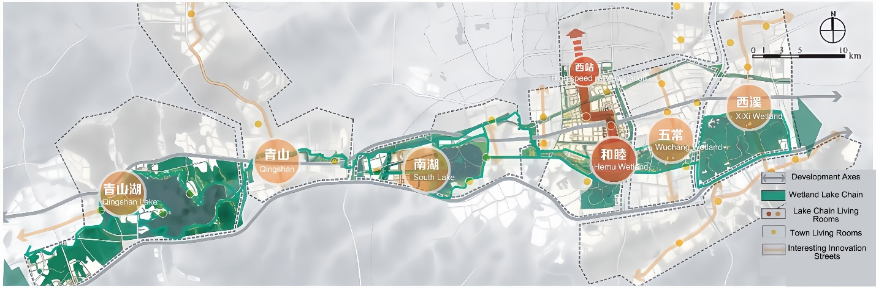

**4.2 Meso-level: Adhering to Entrepreneurial Demands and Organizational Patterns to Promote a Governance Approach for the Diversified Development of Enterprises**

The spatial characteristics of entrepreneurship indicate that entrepreneurs in the Grand Corridor demonstrate a high degree of initiative. In the initial stages of entrepreneurial endeavors and resource acquisition, they predominantly rely on their personal networks. As enterprises grow, there is a gradual shift towards networks constructed by the enterprises themselves. Consequently, it is imperative to implement differentiated policy provisions and spatial supply strategies tailored to the diverse needs of enterprises at various developmental stages in institutional design.

For start-up enterprises, increased financial grants and resource-matching initiatives should be provided. Specialized venture capital funds or guiding funds targeting startups should be established, and social capital should be actively encouraged to participate in the incubation service ecosystem for startups. This will facilitate the establishment of collaborative mechanisms between startups and other enterprises, industry associations, scientific research institutions, etc.

For grow-stage enterprises, market-oriented expansion is the linchpin. This can be achieved by strengthening intellectual property protection, establishing robust channels for industry-university-research collaboration, streamlining administrative procedures, and enhancing resource integration and operational efficiency. These measures will continuously broaden the avenues for socialized innovation , thereby meeting the growth needs of enterprises.

For mature enterprises, the focus should be on enhancing their industry-leading capabilities and promo the construction and expansion of their industrial ecosystems. This can be achieved by encouraging continuous innovation and the cultivation of new industries through research funding subsidies and innovation platform collaborations. Support for talent acquisition should be provided through talent recruitment programs, vocational education initiatives, and the development of supporting infrastructure. Additionally, facilitating upstream and downstream cooperation and innovation within the industrial chain through information-sharing platforms and industry alliances will be crucial.

For declining enterprises, facilitating industrial transformation, optimization, or orderly exit can be achieved through the introduction or collaboration with new industries, the establishment of an orderly exit mechanism (such as transformation subsidies, M&A collaborations), employee resettlement and education, as well as the reuse of inefficient spaces.

**4.3 Micro-level: Design Strategies Prioritizing Human-centric Needs to Foster a Diverse, Integrated, and Inclusive Innovative Spatial Environment**

Given the characteristics of the regional practitioners, which are youthfulness and high educational attainment, there are distinct differences in their demands for facilities and venues related to work, life, entertainment, and leisure compared to those in typical urban areas. Therefore, the spatial supply in the Grand Corridor should center on the needs of practitioners, through urban design methods, solutions should be proposed to meet the humanistic needs of various groups, and a diverse, composite, and characteristic shared spatial environment should be jointly constructed in the region.

Firstly, various functions should be organized with public spaces as the core, creating a high-quality open public space system that serves as an "entrepreneurial and innovative haven "in the Grand Corridor. Taking advantage of the region's favorable ecological environment, the construction of public spaces should emphasize the integration of ecological advantages with entrepreneurial landscapes, shaping urban memories and a sense of place that combines innovative culture with ecological culture, thereby fostering more possibilities for entrepreneurial and innovative activities.

Secondly, in terms of land utilization, a human-oriented approach should be adopted to augment the flexibility of land use. The composite utilization of industrial land should be actively encouraged, fostering spatial integration and innovation. New spatial units that integrate multiple elements, such as entrepreneurial campuses, innovative parks, maker communities, creative scenic areas, and intelligent manufacturing industrial zones, should be constructed in accordance with local circumstances, forming environmental carriers conducive to communication and innovation. In the layout of living areas, boundaries between production and daily life should be boldly broken, encouraging the composite development of small-scale, non-polluting industries with other functions to create living spaces with community-based industrial functions.

Thirdly, in terms of facility support, it is imperative to prioritize the equitable distribution and accessibility of diverse facilities across the industrial spaces within the region. Life service facilities should be provided to cater to the differentiated needs of multi-level talents in the innovative industries. This includes not only facilities for the general public but also tailored for practitioners. Attention should also be given to the psychological, emotional experiences, and value identification of various groups. While ensuring convenient and economical facilities for employees, cultural, artistic, commercial, and leisure functions should be integrated to enhance the region's cultural, recreational, and service capacities for multi-tiered talents. Spatially, it's important to monitor and adapt to demand changes over time, such as upgrading educational and healthcare facilities to meet the evolving needs of a younger workforce.

Additionally, for micro-architectural spaces, greater importance should be attached to the design of communication and learning areas, with a focus on integrating natural elements. Functions such as ecology, leisure, and entertainment should be embedded to soften the work environment and infuse innovation spaces with a human touch. Utilize natural elements such as water bodies and green plants to create leisure spaces, establish public dining, entertainment, and fitness centers, and promote the formation of informal learning and communication. Exploring the integration of office landscapes, ecological landscapes, commercial landscapes and tourist landscapes, foster a sustainable and vibrant ecosystem that promotes economic, social, and cultural coprosperity. This also serves as a response at the planning level to the needs of practitioners.

**5 Conclusion**

This paper, adopting a human-oriented and demand-side-oriented perspective, delves into the spatial needs of the key actors in innovation districts—entrepreneurs and employees. This analysis facilitates the formulation of more precise and effective strategies for constructing innovation spaces, thereby promoting higher-quality development of innovation districts.

The research findings, exemplified by the case of the Hangzhou West Science and Technology Innovation Corridor, indicate that: ① Demographic Traits: Entrepreneurs exhibit localized, youthful, highly educated, and experienced individual traits, daring to actively start their own businesses; employees are localized, youthful, highly educated, and have stable mobility, pursuing self-worth. These traits are associated with the region's "mercantile" cultural characteristics. ② Spatial needs: Enterprises at different stages present different resource needs and spatial choices. Startups prioritize low costs and convenience, growing enterprises focus on the potential for specialized development, mature enterprises emphasize access to human resources and future expansion possibilities, while declining enterprises look forward to the reuse of inefficient spaces; employees prioritize personal growth over employment cost considerations, and employees of different age groups have varying motivations for job location choices and needs for spatial amenities, leading to different spatial location choices. ③ Local supply: Existing planning focuses on the supply of industrial spatial resources in the region, with insufficient attention to startups and declining enterprises; the supporting industrial spaces in the region still follow traditional layouts, neglecting the special needs of high-quality talents in innovation districts.

This represents a novel endeavor in innovation research. This line of thinking, which reflects on innovation district governance by focusing on the genuine needs of practitioners within these districts and their spatial manifestations, has broadened the perspectives of innovation research. It offers solutions to the prevailing issue where past innovation district planning has overly emphasized "spaces of representation" while neglecting the practical demands of industrial development. This study reveals the inherent connections between spatial production and socio-economic activities within these districts, emphasizing the pivotal role of a people-centered, demand-oriented planning philosophy in innovation district governance.

Specifically, the strategic recommendations proposed in this study encompass various aspects, including the construction of regional innovation context, spatial layout optimization, improvement of functions and facilities, and innovation in policy incentive mechanisms. These recommendations aim to build a regional entrepreneurial ecosystem that not only stimulates innovation vitality but also meets the diverse needs of multiple stakeholders. For the Hangzhou West Science and Technology Innovation Corridor, these suggestions will help further clarify its developmental positioning, optimize spatial and resource allocation, and enhance regional innovation capabilities and competitiveness.

Therefore, the findings of this study not only provide targeted and actionable strategic recommendations for the planning and governance of the Western Hangzhou Science and Technology Innovation Corridor but also serve as a valuable reference and model for the sustainable development of other innovation districts. Moreover, this study enriches the data resources and analytical frameworks for subsequent related research, encouraging more scholars to explore the growth patterns and developmental trajectories of innovation districts from multi-dimensional and in-depth perspectives, jointly promoting the prosperity and development of the innovation research field.

**Referencing**

[1] Wang, G. T. (2017) On Supply-Side Structural Reform and New-Type Urbanization, *Urban Planning Forum,* (1), pp.10-18.

[2] Li, Q. H., Huang, L., & Zhang, S. H. (2021) Can the Establishment of National High-Tech Zones Improve Urban Total Factor Productivity? - A Path Analysis Based on TFP Decomposition Data of 261 Prefecture-Level Cities, *South China Journal of Economics,* (03), pp.54-72.

[3] Pan, H. X., & Wang, Z. Z. (2020) The Impact of Spatial Unit Selection and Multi-Dimensional Factors on the Effectiveness of Jobs-Housing Balance, *Urban Planning Forum*, (2), pp.25-31.

[4] Liu, M., & Yan, H. (2018) Coordinated Construction of Urban and Rural Basic Public Service Facilities under the Guidance of Supply-Side Reform: A Case Study of Changzhou Economic Development Zone, *Urban and Rural Planning*, (01), pp.93-99.

[5] Yue, J. M., & Ye, K. H. (2019) Research on the Optimization of the Development Path of Public Facilities in New Urban Areas, *Urban Development Studies*, 26(06), pp.133-140.

[6] Ta, N., & Shen, Y. (2020) Activity Space Segregation and Its Influencing Factors of Suburban Community Residents in Shanghai Based on the Degree of Sharing, *Acta Geographica Sinica*, 75(04), pp.849-859.

[7] Li, M. X., & Xiao, Y. (2023) A Comparative Study on the Spatial Differentiation of Residence, Employment, and Activities of New Immigrants in Shanghai, *City Planning Review*, 47(04), pp.72-78.

[8] Lefebvre, H. (1991) *The Production of Space*. Wiley-Blackwell.

[9] Castells, M. (2003) *Information Age: Economy, Society and Culture (Trilogy).* Translated by Xia, Z. and Wang, Z. Social Sciences Academic Press.

[10] Harvey, D. (1985) *The Urbanization of Capital*. The Johns Hopkins University Press.

[11] Harvey, D. (2010) *Paris: Capital of Modernity.* Guilin: Guangxi Normal University Press.

[12] Soja, E. W. (1996) *Thirdspace: Journeys to Los Angeles and Other Real-and-Imagined Places*. Wiley-Blackwell.

[13] Wu, N. (2008) Lefebvre's Political Reflections on Space, *Theory Journal*, (5), pp.67-71.

[14] Aoyama, Y. (2009) *Entrepreneurship and Regional Culture: The Case of Hamamatsu and Kyoto, Japan*, Regional Studies, 43(3), pp.495–512.

[15] Zahra, S. A. (1996) *Technology Strategy and New Venture Performance: A Study of Corporate-Sponsored and Independent Biotechnology Ventures*, Journal of Business Venturing, 11(4), pp.289-321.

[16] Batjargal, B., Hitt, M. A., Tsui, A. S., et al. (2012) *Institutional Polycentrism, Entrepreneurs' Social Networks, and New Venture Growth*, Academy of Management Journal, 56(4), pp.1024-1049.