Spatial Development Strategies and Policy Recommendations for Social Development in Shenzhen

Author’s Name: Mao, Weifeng

Affiliation:Guangzhou Urban Planning & Design Survey Research Institute Co., Ltd.

Email: weifeng.mao29@gmail.com

**Abstract**

This paper examines the current challenges in the spatial dimensions of our city's social construction efforts, including the low level of resource allocation efficiency, inadequate expression of urban characteristics, and shortcomings in management systems. It offers reflections on the issues and underlying causes affecting social construction in our city. Drawing on successful practices in social construction from both domestic and international contexts, the paper proposes relevant spatial strategies aimed at activating existing spaces, expanding incremental development, prioritizing community engagement, supporting vulnerable groups, enhancing citizens' well-being, and innovating institutional mechanisms.

**Keywords:** Social Development; Spatial Strategy; People-Oriented; Sense of Well-Being

Looking back at the history of Shenzhen's reform and opening up over the past 40 years, economic construction has always been the centre of development, while the development of social construction has lagged , becoming a ‘bottleneck’ that further restricts Shenzhen's sustainable economic and social development. As a pioneer city of China's reform and opening up, Shenzhen has long faced challenges in integrating economic development with social construction, as the lack of effective synergy has led to high property prices, congested traffic and increasing social pressure, seriously affecting the sustainable development of Shenzhen. Urban planning, as a tool for regulating urban development and construction, plays an important role in guiding coordinated economic and social development. Looking at developed cities at home and abroad, all of them give full play to the comprehensive, macroscopic and holistic role of urban planning to promote the sustainable development of cities.

1. **The top-down social construction model is difficult to adapt to the requirements of Shenzhen's transformation and development**

In the 40 years since the establishment of the Shenzhen Special Economic Zone, while creating a world miracle of economic development, urban social construction has also made remarkable progress. However, in terms of spatial support for social construction, it is basically a big deal for the government, and there is still a gap between its top-down spatial allocation model and that of advanced cities, which is mainly reflected in:

* 1. Spatial resource allocation for social construction needs to be optimised

There is a shortage and a waste of spatial resources for social construction. There is a shortage of community-level service facilities compared with the relatively well-developed urban-level service facilities. Shenzhen has highlighted some of its large-scale facilities, completing the construction of public facilities with a high starting point and high standards, such as the Shenzhen International Convention and Exhibition Centre, the Universiade venues and the Shenzhen Concert Hall. However, there is a relative shortage of community-level service facilities compared to urban-level facilities. The population served by social service centres in Bao'an District, Luohu District and Longhua New District, where community population density is high, is 2-3 times that of other districts, and the service carrying capacity of community facilities is relatively weak. The network of grass-roots cultural and sports facilities is not yet complete, with only seven districts having cultural centres and two streets having cultural stations; cultural centres and libraries outside the original Special Administrative Region are not up to standard, and the construction of grass-roots sports facilities needs to be stepped up.

On the other hand, existing facilities, whether in education, health care, elderly care or housing, are being used inefficiently and resources are being wasted to varying degrees. Concerning medical and health facilities, large and medium-sized hospitals are overcrowded and operating at excessive capacity. Primary healthcare facilities, on the other hand, are cold and quiet, and are even struggling to survive. With regard to elderly care facilities, the total occupancy rate of institutional elderly care facilities is only 49.3%, with the occupancy rate of privately-run elderly care facilities at 18.9%, and a large number of facilities and equipment lying unused; whereas the total number of elderly people on the waiting lists of the Luohu Welfare Centre and the Nanshan District Welfare Centre at the end of 2023 amounted to 1,700, and the distribution of beds does not match the distribution of the elderly population. Social welfare facilities such as social welfare homes for vagrant mental patients and children are lacking. With regard to cultural and sports facilities, the efficiency of the use of some of the large cultural and sports facilities is generally low, such as the low utilisation rate of the Universiade venues, the yearly number of visitors to the Guanshanyue Museum of Art in Shenzhen is around 100,000, and the annual number of visitors to the Hexiangning Museum of Art is no more than 80,000, for example.

* 1. Social construction needs to be elevated

The current social construction is based on the protection of people's basic needs, and it is difficult to meet people's ever-increasing material and cultural needs. Aristotle once said: ‘People gather in the city in order to live, in order to live better in the city.’ People living in cities not only need to solve the basic problems of food, clothing, housing and transport, but also need to live a happy and joyful life.

However, Shenzhen's urban space shaping has yet to fully reflect the characteristics of a coastal city and multiculturalism, and residents lack a sense of belonging and identity. As a coastal city with a long coastline in the east and west, Shenzhen has good conditions for building a coastal eco-city. However, these natural conditions have been neglected in the development process, resulting in the distance of the sea, the reduction of mountains and the pollution of rivers. The proportion of living shoreline is low. Shenzhen has a total of 260.5 kilometres of shoreline, of which about 63 kilometres are living shoreline, accounting for only 24%. Referring to the proportion of public shoreline to the main waterfront shoreline in advanced cities (regions) in the world, Chicago is 68.9% and Sydney is 36.3%, which are both over 30%. Shenzhen's multi-cultural characteristics are not fully perceived by the public. Firstly, history and culture are not sufficiently visible, and protection and utilisation are fragmented. Shenzhen has 1600 years of urban history in Dongguan County and Bao'an County, and 600 years of castle history in Nantou and Dapeng. Although the protection of historical and cultural resources is increasingly important, but the government passively delineates the purple line for strict protection, and can not fully realise the value of historical and cultural resources. The combination with the cultural and creative industries is not high, and in the end, but is not conducive to the protection of cultural resources themselves. Secondly, the implementation of the reform and opening-up culture is less content. At present, the culture of reform and opening up is mostly protected through museum exhibitions; this static and single way of protection can not be a comprehensive display of the reform and opening up of the culture of Shenzhen.

* 1. Institutional mechanisms for social construction need to be improved

There is no clear distinction between the responsibilities and roles that the Government and the market can assume. At present, in the area of social construction, the Government ‘takes care of everything’, with all types of social resources being allocated by the Government from the top down. In terms of construction and investment channels, the government's financial resources are predominant. Social capital, especially social organisations and charitable organisations, does not have good channels for donating funds and land for the construction of various welfare facilities. In social organisation management, the slow development of private organisations has made it impossible to effectively alleviate the social contradictions brought about by the sharp increase in social pressure and the imbalance in income distribution.

There is a lopsided emphasis on disaggregating and implementing responsibilities, and there is a lack of platforms for effectively integrating resources and coordinating interests. As the city's social construction is dispersed among various functional departments, the implementation of vertical ‘article management’, each grass-roots community hangs dozens of signs, the community more from the perspective of meeting the requirements of the assessment of the higher level of government rather than from the perspective of meeting the actual needs of the community to carry out the various tasks. The lack of effective coordination among various functional departments makes it difficult to form synergies, and public properties completed often lack follow-up management and supervision; various departments are unable to share resources, and the public has no way of understanding the social facilities around them. Inadequate mechanisms for acceptance and supervision, which require the participation of multiple departments, have made it difficult to implement planning for social facilities. Mainly reflected in the completion of the transfer of the community, community public facilities are not in accordance with the requirements of the planning and construction, or do not meet the requirements of the sectoral industry norms, resulting in the phenomenon of ‘goods do not match the board’, resulting in low utilization of social facilities, problems also have no feedback or accountability. Existing public welfare facilities, due to mismanagement or being in the hands of developers, are privately contracted for closed operations，losing their original public welfare purpose and becoming ‘tasteless. For example, the Starlight Home for the Elderly has been converted into a mahjong teahouse in many communities.

1. **Successful explorations in the field of social construction both at home and abroad have centred on ‘human development’ to organise all kinds of social resources.**

Although Shenzhen's social construction is in a leading position in the country, there are still certain gaps in terms of space, level and institutional mechanism. Strengthening social construction is an important part of Shenzhen's construction of a modern, internationalised and advanced city, and is also a basic guarantee for the social and urban transformation that Shenzhen is facing. We must look to the developed countries and regions and learn from their successful experience, focusing on human needs and organising all kinds of social resources around human development.

* 1. Efficient and Intensive Spatial Allocation for Social Construction - One-Stop Service in Hong Kong's Municipal Services Buildings

The Hong Kong Municipal Services Building (HKMSB) is a multi-purpose integrated municipal building in Hong Kong, which generally comprises a loading and unloading yard on the basement level, a market on the ground and first floors, a cooked food centre on the first floor, a public library on the third floor, a swimming pool from the fourth floor to the fifth floor, and a gymnasium on the sixth and seventh floors. The LCSD and the FEHD now manage some of the facilities separately. At present, there are 39 municipal services buildings in Hong Kong. Vibrant municipal services buildings not only accommodate a wide range of social activities and provide diversified choices for the community, they are also valuable historical monuments in their own right. At least one community cultural complex is encouraged to be provided in each urban living cluster, where the basic needs of life, such as markets, catering, libraries, activity rooms, and so on, are concentrated in a single building, so that residents can enjoy diversified and multi-level as well as ‘one-stop’ services without having to go out of their neighbourhoods.

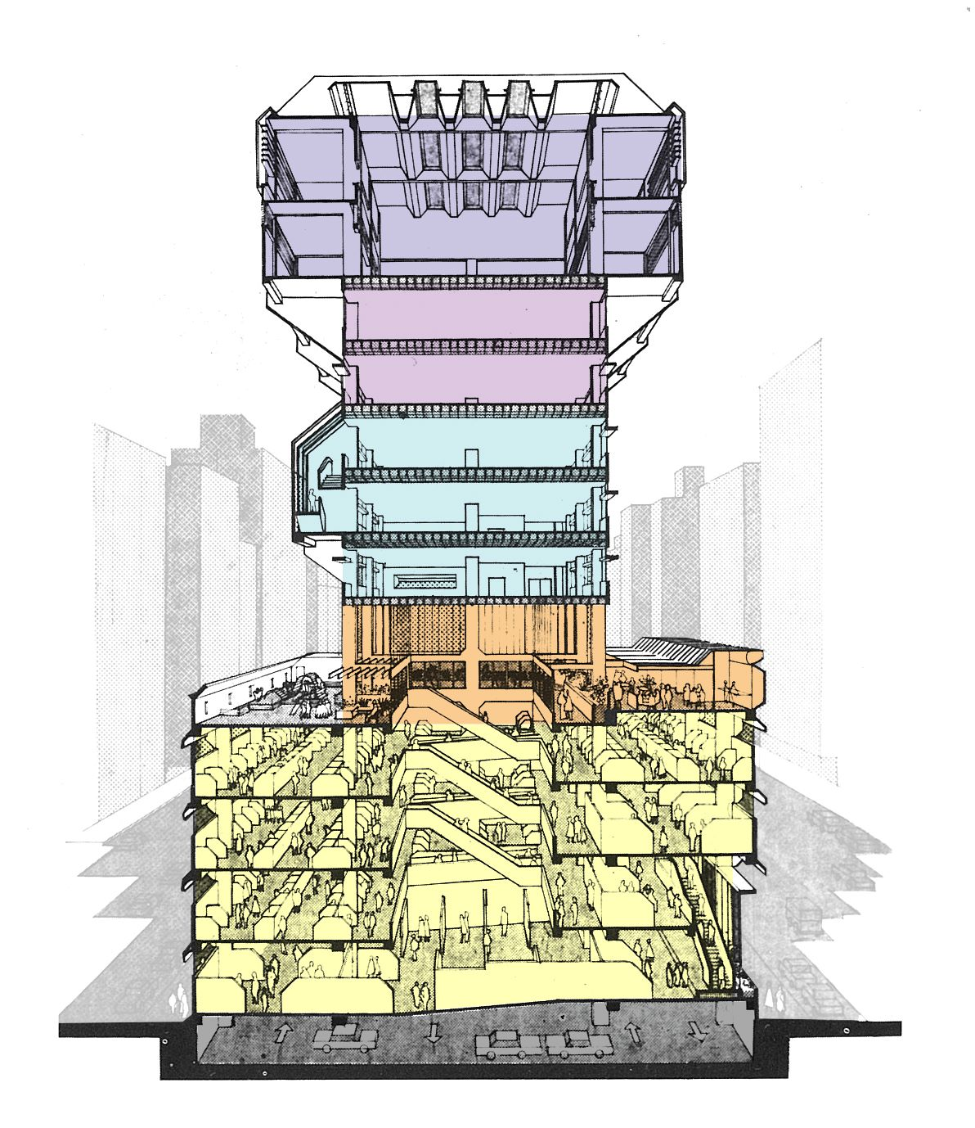

Section of Hong Kong City Hall (source from：zhutaostudio.com）

* 1. High Starting Point, Forward-looking Social Construction Service Model - The Mature Senior Living Community Model in the US

Retirement communities in the United States are generally divided into five categories: Active Adult Retirement Communities, Self-Care Communities, Assisted Living Communities, Special Care Communities, and Mixed Continuing Care Retirement Communities. Active Adult Retirement Communities are primarily for active, healthy seniors between the ages of 55-70 years old. This type of retirement community basically eliminates the need for medical care, but does allow for the use of third-party-provided services such as housekeeping, sanitation, and health care. The amenities that go along with them are more dynamic and include gyms, swimming pools, and golf courses. Self-care communities are for seniors aged 65-80 who do not need assistance with daily living, but do require medical care. The services required are mainly catering, housekeeping and cleaning services, with supporting facilities such as gyms, swimming pools and libraries. The occupants of assisted living communities are mainly elderly people aged 75 and above who need help. The level of medical care required is higher, requiring three meals, bathing, toileting, medication reminders, physical rehabilitation training, etc. Activity rooms, libraries, exercise and rehabilitation centres are required. Special care communities provide the highest level of medical care, including medically prescribed professional rehab, and 24-hour emergency care. Supporting facilities are primarily recreational facilities, exercise and rehabilitation centres, and physical therapy rooms. Hybrid Continuing Care Retirement Communities are a combination of the previous types of retirement communities.

Elderly communities in the United States are already very mature, with different types of elderly communities for different ages and different self-care abilities of the elderly, as well as different modes of management and profitability. This model of community care for the elderly, which is truly considered from the perspective of different needs, is worth learning from.

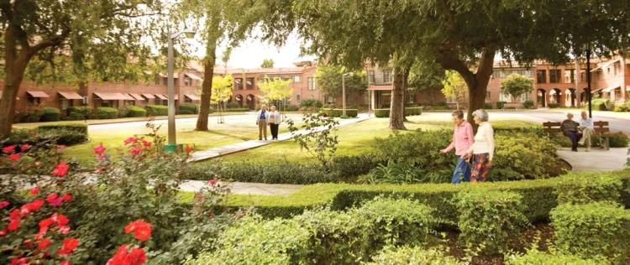

# A schematic diagram of a Continuing Care Retirement Community in the US

# （source from Research: Learning from the middle class pension model in the United States）

* 1. Shared and transparent mechanisms for the management of socially constructed space
     1. Anhui Wuhu ‘Tree of Life’ social service management innovation road

Wuhu City, Anhui Province, has proposed the creation of a ‘tree of life’ information management system, that is, the integration of information resources required in social activities during the different life cycles of human beings, through the establishment of basic databases co-ordinated by various departments, and the initial construction of three-level convenient service enquiry systems for districts, neighbourhoods and communities, with several functions such as household registration management and address management, and at the same time At the same time, information on house ownership, social security, civil affairs, etc. is gradually integrated into the basic database, and several application sub-systems are established, so that all community work is integrated into information management. Information-sharing platforms for all urban and rural communities in the city are gradually being established and covered.

This innovative management model for social services establishes an information platform whereby all sectors of society can more easily grasp information on all types of social services, and government administrations can provide public services more effectively.

* + 1. Operation of Public Properties by the Government Property Agency of the Hong Kong Government

The Government Property Agency (GPA), a department under the Financial Services and the Treasury Bureau of the Hong Kong Government, was set up in 1990 to consolidate the management of government properties, which at that time were scattered in the Chief Secretary's Office, the Lands Department and the Rating and Valuation Department, into a single department. Its core objective is to manage government properties efficiently and cost-effectively. Its main activities include the construction, acquisition or leasing of public properties to optimise the use of government, agency and community land through the reservation of land, the release of under-utilised government land where appropriate, and the vetting of bureaux and departments' office and accommodation requirements.

As the government's industrial coordination and management department, it participates in the supply, planning, construction, operation, supervision and management of the city's public welfare properties, and coordinates the management of the city's public welfare properties in an all-around way. For private organisations in need of acquiring and leasing properties, it provides more convenient and favourable application conditions that are open and transparent.

1. **Strengthening spatial integration to build a people-centred social construction system**

The successful exploration of advanced cities at home and abroad in the field of social construction embodies humanistic care everywhere. Their spirit and philosophy of focusing on human development and putting people first, as well as their successful practical experience, have brought valuable lessons to Shenzhen. Given the existing situation in Shenzhen and some of the problems in social construction, we propose six spatial strategies to cope with social construction, taking space as the entry point:

* 1. Activate the stock of space and encourage the mixing of functions and flexible transformation within the social service space

Ensure the efficient recycling of facilities by converting them to the most needed use of the moment when appropriate. Maximise the value of socially constructed space by adapting, optimising and overlaying internal functions over time. Based on the functional access guidelines, the land use of buildings or public spaces at different times of the day can also be used for different purposes, to achieve the purpose of realising as many uses as possible on the smallest possible plot of land. For example, sports and recreational facilities in primary and secondary schools can be conditionally opened to the community during holidays. Surplus office and conference space in the public sector can be opened up to the community when it is not in use, so that it can be converted into a venue for the activities that the community needs most.

Existing public welfare facilities are encouraged to renew and renovate themselves and increase their floor area ratios in order to expand the space available for use. As the level of urban construction and quality of life continue to improve, when the original public welfare facilities in terms of quality and quantity have gradually failed to meet the needs of residents, in the case of the surrounding land can not be further expanded, can be guided by the planning premise, by applying for the use of the government property maintenance fund or the public-private partnership model, undertake demolition and reconstruction or addition of the existing public welfare facilities in order to expand the use of space, so that they can independently complete the renewal and revitalisation. In this regard, the Government will continue to assist these facilities to enable them to complete their renewal and revitalisation on their own.

* 1. Enlarge the incremental space and release more space for social services in multiple ways

By focusing on internal potential, the government can encourage the reuse of idle or abandoned land or non-construction land for social service facilities. Guiding public participation in the supervision and management of idle or abandoned land suitable for development, and formulating preferential policies to encourage its reformation and utilisation as places or facilities needed by society. In urban landscape zones, green areas and other urban green open spaces under certain conditions, the government takes the lead in designing public facilities and public open spaces that are easily accessible and usable by the public. Encourage the construction of temporary outdoor activity facilities such as tennis courts and football pitches, and revitalise existing non-construction land resources.

Encourage owned buildings to provide public space after the renewal of the building, as well as the surrounding environment through policy instruments such as floor area ratio (FAR) incentives. Further increase efforts to support the transformation of old factory buildings, encourage urban renewal to provide public space, and encourage old factory buildings and other buildings to contribute more public facilities through such means as the distribution of land proceeds, land-price adjustments, and the transfer of plot ratios.

* 1. Focus on the community level and promote social service facilities at the community and grassroots levels

Optimising the scope of community management and services. Explore the establishment of basic community statistical units, and set up a system of basic community statistical units linking professional departments such as planning, land, property, statistics, public security, education and health. Change the statistical system in which each unit works separately and does not interfere with each other, integrate information on spatial and social management resources such as healthcare, culture and sports, education, population and public services, and implement a comprehensive and all-encompassing community statistical system. Integrate various types of statistical units, including those of planning, public security, education and other departments. Allocate social service facilities according to the actual population size. Break down the traditional community boundaries based on administrative boundaries, and determine the scale and type of various types of facilities according to the size of the actual population living in the local area, and establish a service-oriented mechanism for the allocation of community spatial resources. Under a market-based mechanism, the scale and structure of community service personnel of all types are configured around the needs of the community in accordance with factors such as the size of the population served and the carrying capacity of the community, and community boundaries are dynamically adjusted to form a scientifically reasonable physical community boundary for community management services.

Strengthening the provision of grass-roots facilities such as community-level sports and cultural facilities and medical facilities. For example, in response to the shortage of sports venues, increase the construction of community-level simple basketball courts, simple fitness facilities and other grounded, fast-acting and inexpensive cultural and sports facilities. Ensuring the availability of community-level service facilities. Appropriate policy preferences will be given in terms of supporting land for community service facilities outside the original Special Administrative Region or in short supply. Open a ‘green channel’ for the approval of land for community-level facilities, and simplify the content and procedures for the approval of land for community facilities, so that they can be put into use within the shortest possible time. A multi-sectoral acceptance system has been established to ensure that community facilities meet the normative requirements and practical needs of various sectors.

* 1. Care for the disadvantaged and provide diversified spaces and services for different people in the city

Through differentiated spatial strategies, different groups of people in the city can have their own place and enjoy themselves. Improving the living space for low- and middle-income groups in urban villages and other cities. To address the housing problems of low-income groups, broaden the supply of secure housing by actively promoting urban renewal modes such as conversion of industrial buildings into residential buildings and renewal of allotments, and make good use of the self-renewal mechanism of urban villages. In such a densely populated place as Haisha Village, where water cannot be splashed in, a new underground car park of several thousand square metres has been built, and the decoration of shops on the ground floor of the streets of Shuiwei Village is becoming more and more fashionable. Give some time and policies to allow urban villages to gradually renew themselves; extract some of the buildings to create public activity spaces in urban villages. Perhaps more important than old age reform is to make urban villages more livable. Compared with uprooting, acupuncture-type therapy is more effective.

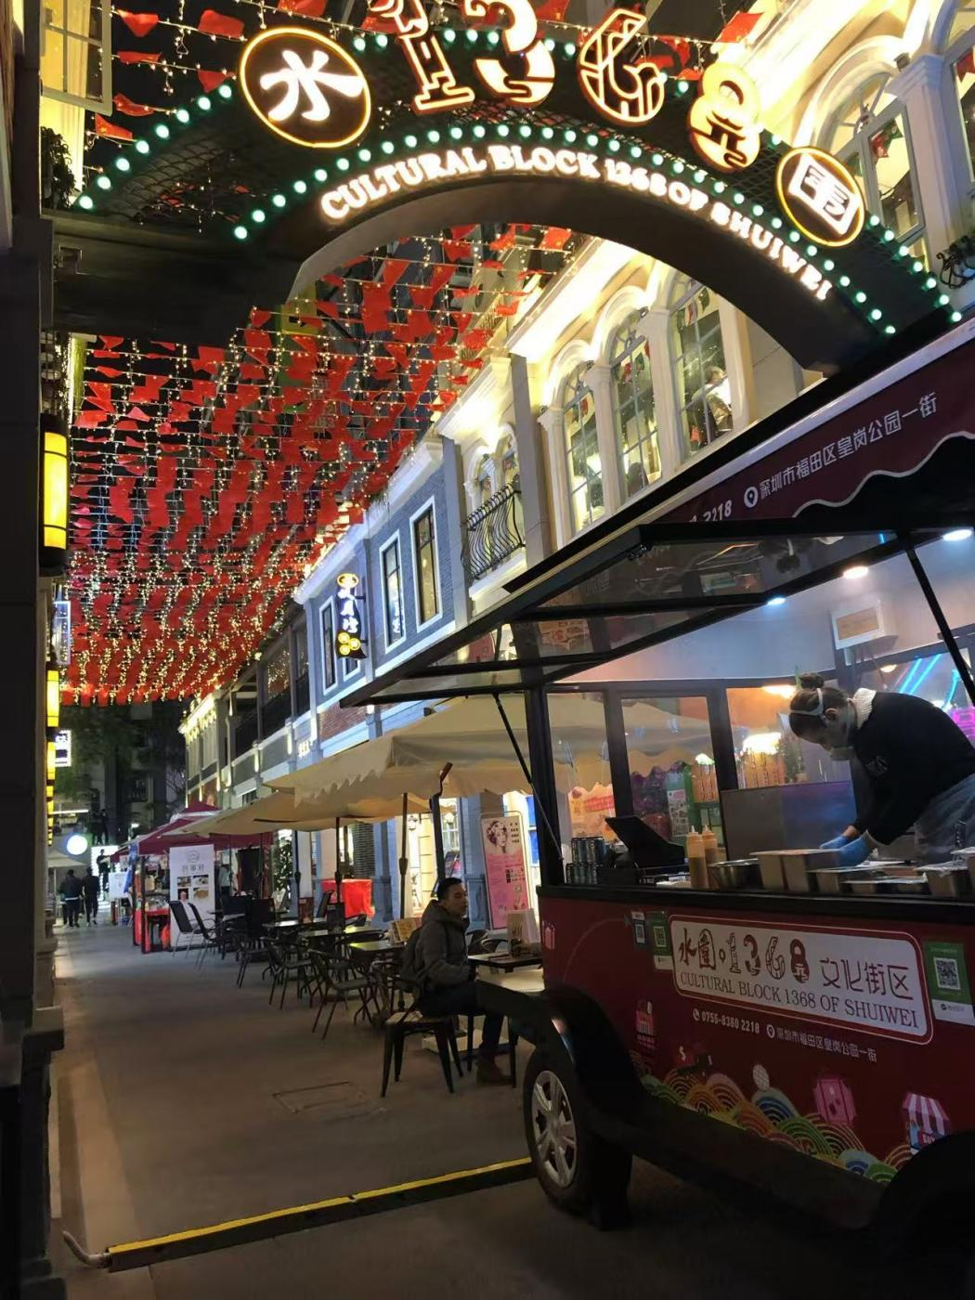

Real scene of 1368 block in Shuiwei Village（Photo by the author）

To open up space for entrepreneurship among low- and middle-income people, such as the Civic Centre Square as a flea market, and regulating its management by fixing its opening time, location and types of commodities, and so on. The Civic Centre Plaza is grand and empty, with no facilities for public recreation, and not well divided and designed, with a large scale and a lack of vitality. The elevated plaza on its north side and the car park on its south side are very underutilised. We can make the Civic Centre Plaza an ideal place for various urban activities and festivals, so that the Civic Centre Plaza can really become a ‘citizens' plaza’. At the same time, an appropriate fee reduction and exemption policy can be implemented, the level of social security for the informally employed can be gradually raised, and the training of the informally employed can be strengthened and improved.

Enhancing accessible design. Tailor humane spaces for women, children and the elderly to enhance the inclusiveness of cities. Improve people-centred barrier-free urban design, provide rehabilitation services or facilities for people with disabilities, adopt universal design, and implement a system of accessibility co-ordination managers and accessibility directors. To address the mobility problems of the elderly, barrier-free facilities such as handrails have been placed in public activity areas, walkways and even the interior of housing in neighbourhoods, and attention has been paid to the elderly in the smallest detail through refined design.

According to the differences in the self-care abilities of the elderly, various types of retirement communities, such as active adult retirement communities, assisted living communities and special care communities, will be fostered. In response to the trend of aging in Shenzhen, we will focus on cultivating ‘residential area + retirement’ type of elderly communities in the future, with architectural designs specially designed for the elderly, giving full consideration to the dual needs of the elderly both physically and mentally, and targeting the planning of recreation, arts and culture as well as the main body of recreational living space, to create an image of a rich and personalised residential area, and to respond to the diversified needs of elderly groups in a flexible and changeable way, and to comprehensively promote the community elderly social community. Flexible and changeable ways to respond to the diversified needs of the elderly groups, and comprehensively promote the socialised service mode of community elderly care. There are different types of retirement communities for different age groups, with different management and profit models.

* 1. Enhance citizens' sense of well-being and shape the characteristics of a city of mountains and seas and a diversified city

Create a strong subtropical coastal city character and improve the quality of life of citizens. Insist on creating high-quality ecological space, and create urban clusters with suitable scales, complete support facilities and balanced jobs and housing; accelerate the establishment of the city's ecological protection and compensation system, and explore a variety of ways, such as eco-community planning, government leasing, and transferring the right to development in ecological areas, so as to realise the protection of resources with the mindset of development; and accelerate the adjustment of the function of the shoreline to increase the proportion of public shoreline. In Shenzhen's 260.5 kilometres of coastal zone co-ordination planning, increase the proportion of the original living shoreline of 25% to 35%; enhance the permeability of the coastal space to the service hinterland, so that the public in their daily activities are more close to the coastal space; cultivate more waterfront space, so that the public can see the mountains, look at the water, get close to the sea, forming an open, pleasant mountain and sea city cityscape; in the streetscapes, park landscapes, architectural styles and sculptural vignettes to reflect the characteristics of the coastal city everywhere.

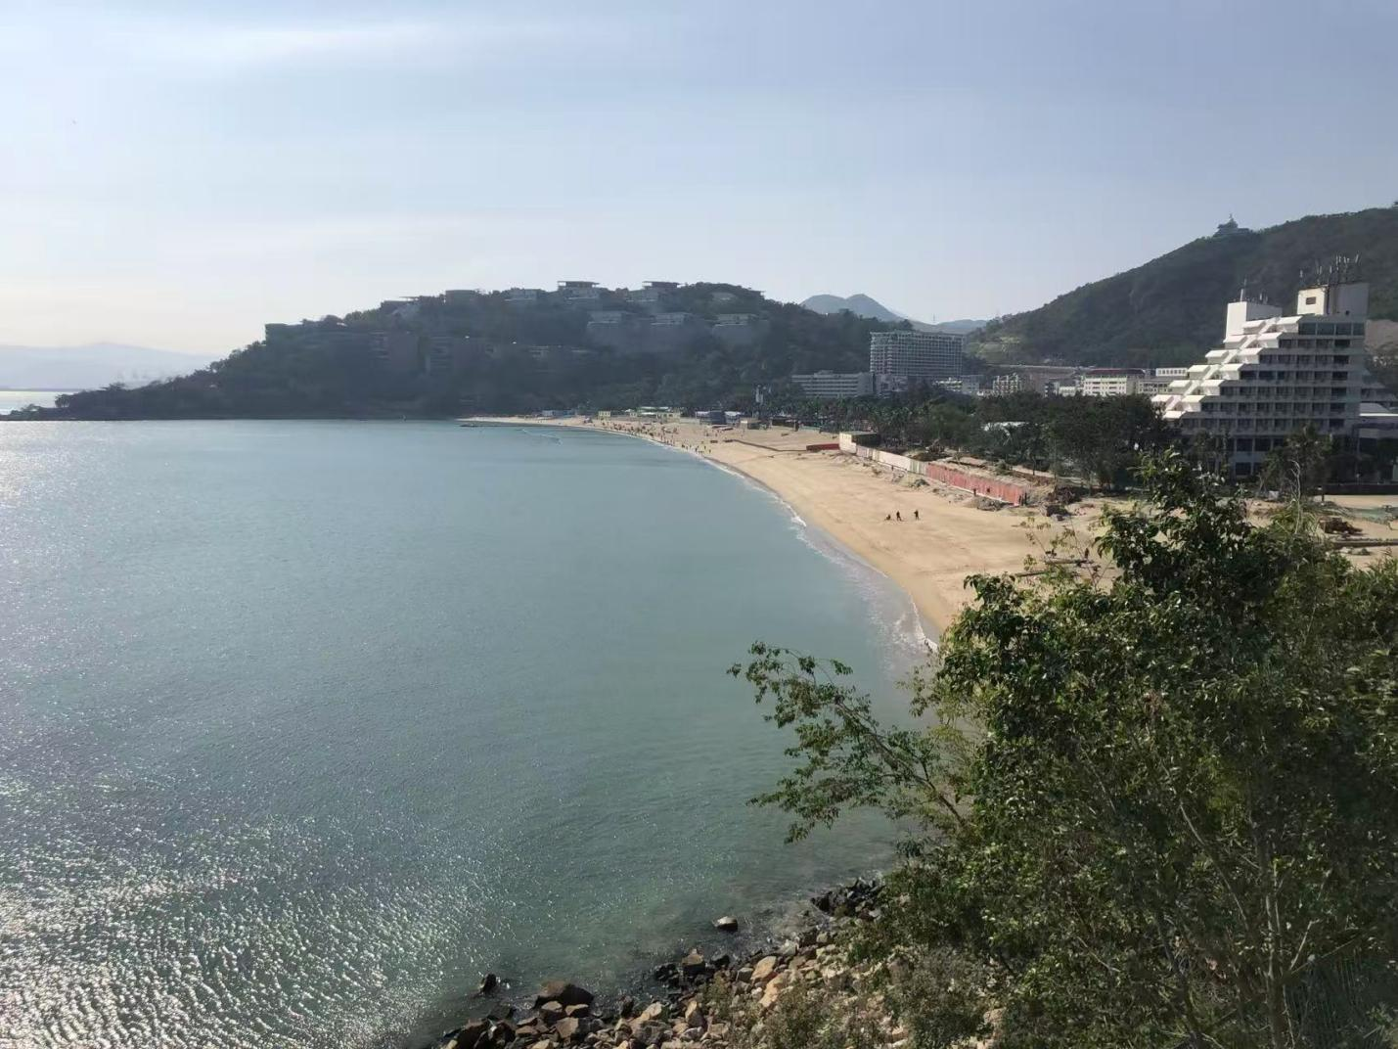

Shenzhen Coastal Corridor（Photo by the author）

Strengthening the ‘diversified and inclusive’ urban culture and spirit of the city, enhancing the citizens' sense of belonging and happiness in their city, and improving the city's cultural competitiveness. On the basis of the diversified cultures of Lingnan culture, marine culture, reform and opening-up culture and immigrant culture that have already been formed in Shenzhen, learn and absorb the cultural development strategies of world-class cities, and, according to Shenzhen's strategic concept of ‘establishing the city with culture’, reflect the diversity of the city's cultures in the organisation of urban space, layout of facilities, and architectural design, so as to enhance the inclusiveness and cohesion of urban development. To enhance the inclusiveness and cohesion of urban development. Actively promote the protection of ancient villages and the transformation of historic districts. Different protection and utilisation methods will be adopted for different types of ancient villages, so as to achieve ‘original protection’ and ‘functional regeneration’, and to ensure that ancient villages regain their vitality and vigour while retaining urban memory. Regulations on the management, protection and repair of ancient villages should be formulated, and adequate compensation and incentives should be offered in terms of renewal and upgrading, as well as investment in the renovation of municipal facilities. Shape humane and characteristic urban public spaces. Use acupuncture to create a vibrant and interesting Shenzhen, starting from the ‘point’. Use different buildings, places, facilities and vignettes to fully express the spirit of innovation and design. Advocating the small-scale transformation of urban villages, creating public courtyard spaces by removing part of the building; taking into account Shenzhen's climatic conditions, creating all-weather promenades, urban bridges, etc.; and proposing the combination of urban locations and urban activities, such as the Binhai Avenue Bicycle Race and the Civic Centre Festivals.

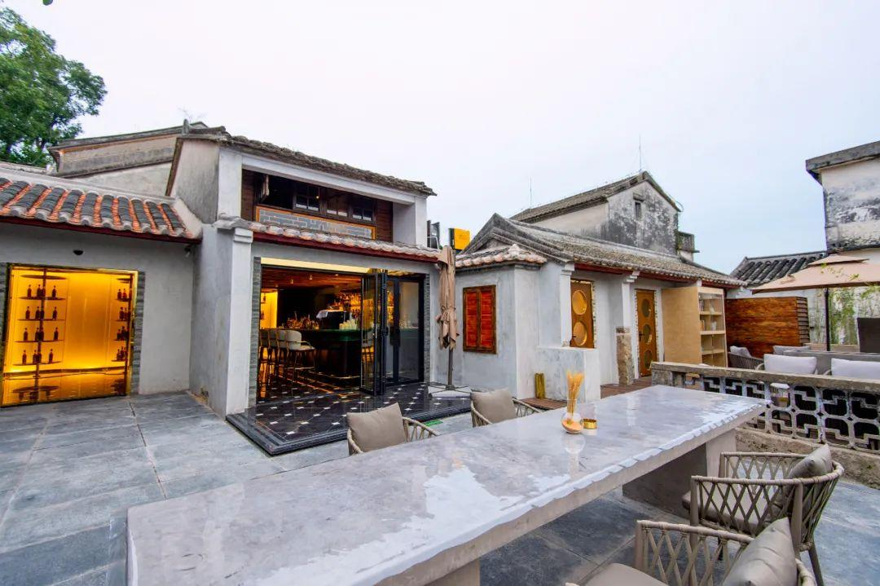

"original appearance protection" + "function regeneration" of Shenzhen Dapeng Fortress（source from sznews.com）

* 1. Innovative institutional mechanisms and the gradual establishment of a working mechanism for sharing resources across sectors

The Shenzhen Public Property Management Agency was created as the government's industry co-ordination and management department to participate in the supply, planning, construction, operation, supervision and management of public property throughout the city. The Public Property Management Agency is mainly responsible for the operation and management of government and other public welfare properties in the city, and coordinates the supply of land, planning and construction of new development programmes in response to the demands of various functional departments for land for public facilities. Through conversion or renovation, purchase or lease, it flexibly provides housing for social construction services and, where appropriate, vacates underutilised government properties to ensure that the city's public property land use efficiency is maximised.

Developing a ‘one account’ information network platform at the municipal, district and community levels. Integrate information on healthcare, culture and sports, education, population, and public service space and social management resources, and unify and publish them on the livelihood facilities supply information platform, which will be dynamically updated and maintained according to the use of the facilities, and gradually promote the sharing of public resources managed by different departments. All sectors of society can more conveniently grasp the latest information on the use of social construction space, and apply to public property management organisations on the platform to rent space, as well as apply for the construction or acquisition of certain properties for specific projects.

Open up channels to guide individuals, enterprises and charitable organisations to contribute facilities and services to society. Gradually relax the restrictions on social organisations entering the field of social construction, study and formulate a variety of incentives such as relevant land prices, plot ratios, taxes, etc. to support the entry of private capital into the social sector, and encourage social capital to participate in the construction of livelihood-type facilities through various modes such as BT and BOT. Encourage individuals to contribute to society by transforming land or buildings in their hands into public facilities and open spaces such as parks, squares and promenades for charitable purposes. A professional operation mechanism of contribution-assessment-distribution-management has been established to respond quickly to current public needs.

Improving mechanisms for the participation of all of society in social construction. Reinforcing the participation of relevant authorities in civil affairs, education, health and human rights, culture and sports in the entire process of social construction projects, including the entire process of planning, approval, acceptance and management, will make it easier for the competent authorities to improve their own sectoral plans promptly and to promote the construction of relevant facilities in due course. Gradually establish a mechanism for teachers, doctors, lawyers, planners and other professionals and technicians related to social construction to share their professional knowledge and serve in social construction. In conjunction with the community planner system, a counselling and service platform for professional and technical personnel has been established in the community to provide a full range of services to community residents regularly.

**Reference**

1. Lan Fan. (2015). Spatial Development Strategies for Public Service Facilities in Shenzhen. (eds.) The New Normal: Inheritance and Transformation —— Proceedings of the 2015 China Urban Planning Annual Conference (09 Urban Master Plan) (pp.477-485). Shenzhen Planning and Land Development Research Centre;
2. Liu Yonghong, Mao Weifeng & Lan Fan. (2019). Reflections on the Allocation of Spatial Resources for Social Construction in China: A Case Study of Shenzhen. Chinese Cities, (05),12-17.
3. Shenzhen Municipal Commission of Planning and Land Resources (2013), Research on spatial strategy for social construction in Shenzhen
4. Liang Junqian (2016). Exploration of Shenzhen's Planning, Development and Social Construction. Shenzhen: Haitian Publishing House
5. Liu Yonghong (2017). Urban Planning and Social Construction: A Case Study of Shenzhen, Famous Cities in China
6. Huang Yaping (2009). Urban Planning and Urban Social Development, Beijing: China Architecture Press
7. Study on the current situation and planning countermeasures of people's livelihood facilities in Shenzhen
8. Study of Los Angeles, USA: Artist Colony retirement community